Focus Model overview

Contents

Overall Design 3

Input/Output Database Structure 7

Pre-process components outside the feedback loop 10

1. Population Synthesizer (PopSyn) 10

2. Database Stored Procedures 11

3. PopSynOutputProcessor 12

4. TransCAD General Pre-process and Transit Access-Egress 13

5. Size Sum Variable Calculator 13

Model Components Inside the Speed Feedback Loop 15

6. TransCAD Multi-Period Highway/Transit Pre-process 15

7. TransCAD Network Skims 15

8. TransCAD DIA/I-E/E-E Trip Generation; Trip Distribution; Mode Choice 17

9. Regular Work Location Choice 18

10. Disaggregate Mode Choice Logsums 22

11. Regular School Location Choice 23

12. Auto Availability Choice 26

13. Aggregate Mode Destination Choice Logsums 28

14. Daily Activity Pattern Choice 30

15. Exact Number of Tours 35

16. Work Tour Destination Type 39

17. Work-Based Subtour Generation 40

18. Tour Time of Day Simulation 42

19. Tour Primary Destination Choice 43

20. Tour Priority Assignment 45

21. Tour Main Mode Choice 46

22. Tour Time of Day 55

23. Intermediate Stop Generation 62

24. Trip Time of Day Simulation 66

25. Trip Time Copier 67

26. Intermediate Stop Location 68

26. Trip Mode Choice 69

28. Trip Time of Day 72

29. Write Trips To TransCAD 76

30. Assignment, Convergence Test, and Speed Balancing 77

# Overall Design

The Focus travel model is an activity-based model for the Denver region developed by Denver Regional Council of Governments (DRCOG) in conjunction with Cambridge Systematics, Mark Bradley, and John Bowman. Based roughly on Sacramento’s activity-based model, the model synthesizes individual regional households and persons and forecasts their travel throughout a typical weekday based on personal and travel-related characteristics.

The Focus model logit components were estimated using ALOGIT software based on the 1997 Travel Behavior Inventory (TBI) Survey. Focus was then calibrated using a 2005 input dataset and comparing output datasets to existing data such as traffic counts and American Community Survey (ACS) data. Modifications were made to model component coefficients, constants, and variables to bring model results closer to observed data values.

shows the model flow by component and the outputs associated with each component. The model begins with a set of pre-processing steps that are outside the speed feedback loop including a population synthesizer, database creation procedures, and TransCAD processes. The TransCAD skims are created within the feedback loop and then used in several logit model components including the location choice, activity generation, and mode choice models. Tours from home to a primary destination and back home again are the first travel elements to be created. shows a diagram to explain how tours work. This diagram has a tour with three trips, two half-tours, three half-tours stops, and one intermediate stop. The model runs through a set of activity generation, location choice, mode choice, and time of day choice model components for tours. Then the model runs through a parallel set of model components for trips within a tour.

Figure 1. Tour Diagram

Intermediate Stop Location

Tour Destination

Tour Origin

and show the conceptual flow of the model. The Focus model flow is operationally managed by a set of C# code classes, which calls GISDK code and SQL Server Database queries as needed, as is shown in . The C # code runs most model components, including the majority of the logit models. The GISDK code runs the TransCAD processes of highway and transit skimming and assignment. shows that the GISDK code also generates and chooses modes for Internal-External(I-E)trips, External-External (E-E)trips, Commercial and airport trips. The GISDK code base was ported and modified from the trip-based Compass model to serve its purposes in Focus. SQL Server manages sending data to and from the code, inserting new records and updating table values. Java is used for only one model component, the Population Synthesizer.

Figure . Basic Code Structure

The rest of this document will delineate each model component shown in in further detail.For each model component, the following information will be provided: its most significant inputs, its component type (logit, monte carlo simulation, TransCAD process, or special), and its programming language. The next section depicts the database structure.

Figure 2. Model Flow Diagram



Figure . Model Flow for Airport, Internal-External, External-External, and Commercial Trips

# Input/Output Database Structure

Most model components read from and write to the database that holds most of the model data and outputs. For that reason, a brief description of the database structure is needed before details about the model components can be explained. The main location-related inputs are stored on the zones and points table, as shown in . The yellow keys show how the tables relate to one another. For example, the Points table is foreign keyed to the Zones table via the field ZoneID.

Figure 5. Zones and Points Tables

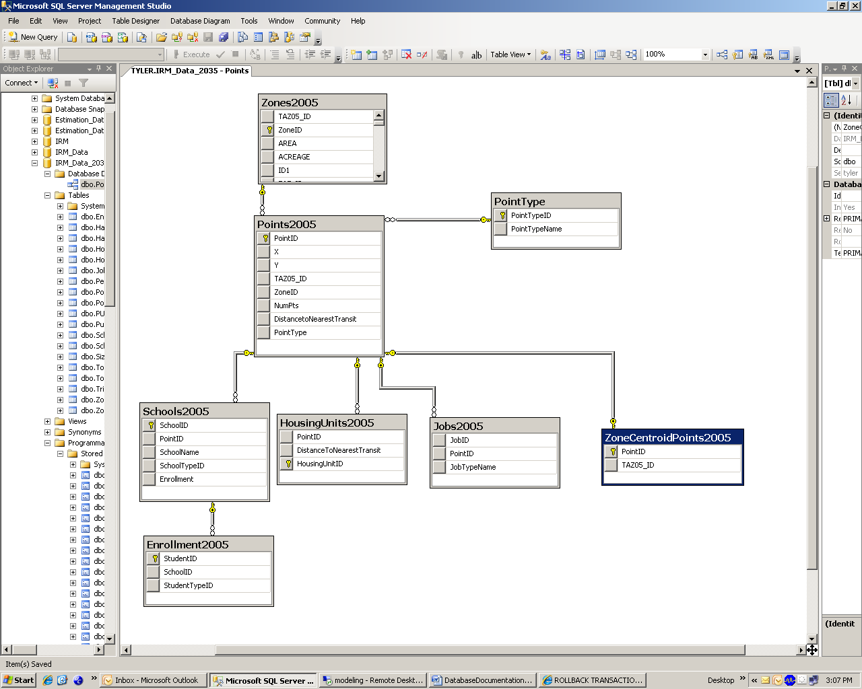

Persons and households input variables are stored on the persons and households tables. shows that people belong to households and are associated with points for their work and school locations. Households are also given a housing unit point.

Figure 6. Persons and Households Tables

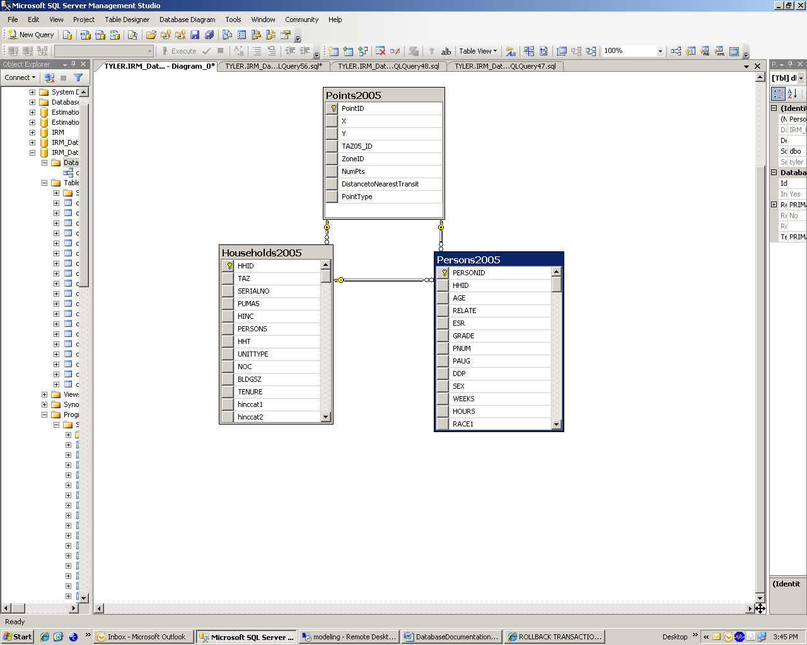

Finally, the persons have trips and tours associated with them that are stored in the tables shown in . The tours and trips have point locations for their origins and destinations.

Figure 7. Tours and Trips Tables

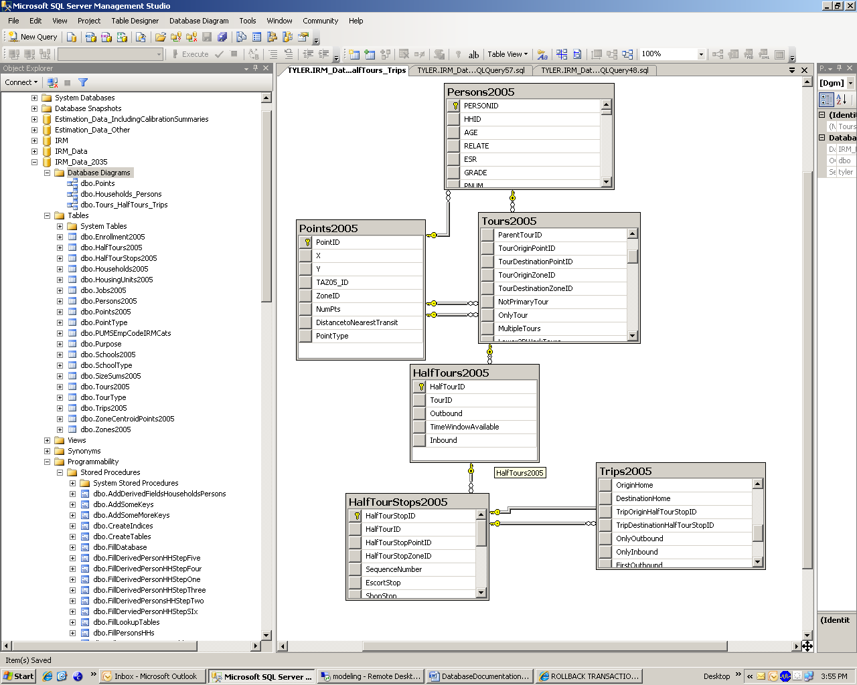

# Pre-process components outside the feedback loop

The following model components are outside the speed feedback loop. This means they only need to be run once per model scenario. These components can be thought of preprocessing steps that set up the basic person and travel related datasets to be used throughout the model.

# Population Synthesizer (PopSyn)

#### Component Type: Special Component

Programming Language: Java

#### Inputs: Regional Total Households by Number of Adults, Presence of Children and Age of Householder, Zonal Households by Income Group and Household Size

#### Outputs: Millions of Household and Person Records with Detailed Demographic Characteristics

The first model component to be run is the Population Synthesizer. PopSyn, which was designed by John Bowman, creates a forecast of individual households and persons with detailed demographic characteristics for chosen year. It operates by drawing household and person records from the 2000 Public Use Microsample (PUMS) with the goal of matching forecasted demographic controls.

The Population Synthesizer uses two sets of controlled variables for household characteristics: regional-level controls and zonal-level controls.  For the PopSyn run, the regional controls come from the economic forecast and the zonal controls are based on the land use model and 2000 Census data.  The zonal and regional controls are depicted in further detail below.

**PopSyn Zonal Controls**

for each of2804 travel model internal zones

(1) Total Households in the Zone

(2) Percentage of Households in Zone with Income 0-30K

(3) Percentage of Households in Zone with Income 30-60K

(4) Percentage of Households in Zone with Income 60-100K

(5) Percentage of Households in Zone 100K+

(6) Percentage of Households of Size 1

(7) Percentage of Households of Size 2

(8) Percentage of Households of Size 3

(9) Percentage of Households of Size 4+

**PopSyn Regional Controls**

sum of all households in 2804 travel model internal zones

1. Households with One Adult, No Children, Age of Householder 18-44
2. Households with One Adult, No Children, Age of Householder 45-64
3. Households with One Adult, No Children, Age of Householder 65+
4. Households with One Adult, With Children, Age of Householder 18-44
5. Households with One Adult, With Children, Age of Householder 45-64
6. Households with One Adult, With Children, Age of Householder 65+
7. Households with Two or More Adults, No Children, Age of Householder 18-44
8. Households with Two or More Adults, No Children, Age of Householder 45-64
9. Households with Two or More Adults, No Children, Age of Householder 65+
10. Households with Two or More Adults, With Children, Age of Householder 18-44
11. Households with Two or More Adults, With Children, Age of Householder 45-64
12. Households with Two or More Adults, With Children, Age of Householder 65+

# Database Stored Procedures

#### Component Type: Special Component

Programming Language: T-SQL

#### Inputs: Households and Persons comma-seprated value (csv) files, Housing Units/Schools/Jobs points csv files, Zone csv table

#### Outputs: All SQL Server Data database tables filled with variables needed for model components and database structure created

The output households and persons tables from the Population Synthesizer are imported into the database structure used to run the Focus model. A set of stored procedures creates a new database and fills it from comma-separated text files for data for persons, households, zones, schools, jobs, and housing units. The procedures also create derived variables from based variables to be used in model components. For example, the variable ln(service density) in the zone is created by the procedures. The procedures also create primary and foreign keys to represent data relationships and ensure data integrity. Finally the procedures add data indices to speed data access. The names of the database procedures are listed below in their order of operation.

1. CreateTables

2. FillLookupTables

3. ImportZonesFillZonePlaces

4. ImportEmpPlaces

5. ImportEmpPlacesStep2

6. ImportHousingPoints

7. ImportSchoolPoints

8. ImportPersonsHHsEmpCodes

9. AddDerivedFieldsHouseholdsPersons

10. FillDerivedPersonHHStepOne

11. FillDerivedPersonsHHStepTwo

12. FillDerivedPersonHHStepThree

13. FillDerivedPersonHHStepFour

14. FillDerivedPersonHHStepFive

15. FillDerivedPersonsHHStepSix

16. InsertZoneCentroidsAsHousingPoints

17. FillZoneIDsonPointsTable

18. UnNullColumns

19. AddSomeKeys

20. AddSomeMoreKeys

21. CreateIndices

# PopSynOutputProcessor

#### Component Type: Monte Carlo Random Selection

Programming Language: C#

#### Inputs: Households Table and Housing Units Table

#### Outputs: Households provided with a housing unit point location, a distance from the household to transit, and a logsum segmentation

After the households, persons, points, and zones have been imported into the database, the PopSyn output processor takes households and using the information about which zone they live in, randomly assigns a housing unit within the zone. Once each household has been assigned a housing unit, fields related to their distance to transit and logsum segmentation are also updated.

# TransCAD General Pre-process and Transit Access-Egress

#### Component Type: TransCAD process

Programming Language: GISDK

#### Inputs: Highway and Transit Networks

#### Outputs: Creates split peak and off-peak networks, updates zonal data file

The TransCAD general pre-process splits combined daily networks into separate peak and off-peak. It also calculates additional fields in zonal data file. The transit access/egress step determines the fraction of each TAZ within 1.5 miles of transit and files those values into the zonal file.

# Size Sum Variable Calculator

#### Component Type: Special Component

Programming Language: C#

#### Inputs: Zones Table

#### Outputs: SizeSums Table filled with all size sum variables used in the model

The size sum calculator is another pre-processing step that creates some zonal variables based on basic zonal values that are used in several model components. The goal of the size sum calculator is to create the variables that will go into the second half of the following equation:



The size sum variable calculator was an effort to adhere to a major project goal was to be able to keep various logit components to be as general as possible. The size sums are made by pre-calculating the part multiplied by Beta (). Then we can treat the size sum like a normal variable and Beta like a normal coefficient when entering this info into the utility function specification. However, the size sum does often depend on person characteristics For instance, in the WorkLocationChoice Model, there are six different possible size sum variables depending on what the person's worker type is. When entering the size sum variable into the database, the size sum has to be entered as six different composite variables (the size sum crossed with the binary variable of the person's worker type), each with the same coefficient (the logsum multiplier). This variable cross looks like the following:

|  |  |  |
| --- | --- | --- |
| **Coefficient** | **Column from zonal table** | **Column from person table** |
| LSM | Education | EducationWorker |
| LSM | Entertainment | EntertainmentWorker |
| LSM | Retail | RetailWorker |
| LSM | Production | ProductionWorker |
| LSM | Restaurant | RestaurantWorker |
| LSM | Service | ServiceWorker |

# 

# Model Components Inside the Speed Feedback Loop

The majority of the model components are inside the speed feedback loop, which means they are dependent on speeds and congestion levels to create outputs.

# TransCAD Multi-Period Highway/Transit Pre-process

#### Component Type: TransCAD

Programming Language: GISDK

#### Inputs: TransCAD highway and transit networks

#### Outputs: Updated highway and transit geographic and network files

After the basic pre-processing steps have been performed, a set of network-related TransCAD processes must be performed that include speed information and are therefore included in the speed feedback loop. The multi-period highway pre-process step is a TransCAD process that creates additional fields in the geographic files and compiles them into TransCAD .net files.

The transit pre-process step is another TransCAD process that copies highway speeds from the correct time period highway geographic file to the peak transit base geographic file. It also creates additional fields in correct time period transit route system and compiles it into a .tnw file.

# TransCAD Network Skims

#### Component Type: TransCAD

Programming Language: GISDK

#### Inputs: TransCAD highway, bike, and transit networks

#### Outputs: Skim Matrices that show impedances for zone pairs, pre-processed variables used in later model components

The highway and transit skims are made by finding shortest paths for origin-destination zone pairs by time-of-day and used extensively for location choice, mode choice, and time of day choice. The skim outputs are a set of matrices that provide the impedance values such as travel time and cost associated with each pair of origin and destination zones. In Focus, special skim matrices are made to pre-process skim-related variables like generalized time and piecewise linear distances.

In highway skimming, model assumes that all travelers will take the shortest generalized cost path between their origin Transportation Analysis Zone (TAZ) and their destination TAZ. The generalized cost is a function of travel time, cost and distance. Highway skims are calculated for ten time periods:

* AM1: 6:30 – 7:00 AM;
* AM2: 7:00 – 8:00 AM;
* AM3: 8:00 – 9:00 AM;
* PM1: 3:00 – 5:00 PM;
* PM2: 5:00 – 6:00 PM;
* PM3: 6:00 – 7:00 PM;
* OP1: 11:00 PM – 6:30 AM;
* OP2: 9:00 – 11:30 AM;
* OP3: 11:30 AM – 3:00 PM; and
* OP4: 7:00 – 11:00 PM.

For transit skimming, the model assumes that a person traveling between two Transportation Analysis Zones (TAZs) will traverse the shortest (least-cost) path, measured by some generalized cost. The generalized cost includes these components:

* Walking or driving time to access a transit stop,
* Waiting time,
* In-vehicle time,
* Walking time and waiting time associated with transfers, if applicable,
* Walking time to egress from a stop to the final destination, and
* Fares.

TransCAD’s Pathfinder algorithm is used to calculate those shortest paths. In the event that the Pathfinder finds two paths with the same or similar generalized costs, it will allocate the fraction of travelers using each path in proportion to the frequency of service on each path. DRCOG uses a cost threshold of 0, meaning that paths will only be combined when their costs are the same. This multi-pathing allows headways for similar routes to be combined, reducing the wait time, and providing added realism over simple shortest path algorithms.

Transit skims are performed separately by four time periods and access mode, of walk to transit or drive to transit. The four time periods are: AM (6 am-9 am), MD (9 am-3 pm), PM (3 pm-7pm) and OP (7 pm -6 am).

For bicycle skims, a fixed speed of 10 mph hour is assumed. The time and distance between each origin-destination zone pair is skimmed. The highway links are used as bicycle facilities with large weights applied to discourage bicycling on large facility types. The Cherry Creek trail is coded with weights to encourage its use. Most bicycle trails are not included in the network at this point.

# TransCAD DIA/I-E/E-E Trip Generation; Trip Distribution; Mode Choice

#### Component Type: TransCAD

Programming Language: GISDK

#### Inputs: TransCAD networks and skims, zone.bin file

#### Outputs: airport, internal-external, external-external trip matrices by time of day

After skimming is run, a set of vestigial Compass 2.0 model components must be run for airport trips, internal-external trips, and external-external trips. The entire Compass model must be run to generate and assign these trips. Please see the Compass documentation and for further details. A brief description of the Compass model steps follows.

The trip generation step generates productions and attractions based on employment and jobs by zone, and then balances the productions and attractions. The trip distribution uses gravity models by home-based work, home-based non-work, internal-external, external-external, and commercial purposes to create origin-destination trip pairs. The mode choice model is a logit model assigns each trip a mode from the following mode choices: Drive Alone, Shared Ride 2, Shared Ride 3+, Walk to Transit, and Drive to Transit.

The resulting airport, internal-external, external-external, and commercial matrix rows and columns are later combined with the matrices created from the internal-internal person trips by WriteTripsToTransCAD to create the final trip matrices by time-of-day that are assigned to the highway and transit networks.

# Regular Work Location Choice

#### Component Type: Nested Logit

Programming Language: C#

#### Inputs: Skim matrices, persons and households table, zones table, job points

#### Outputs: all Workers assigned a regular work location zone and point location

Using the skim matrices, the work location choice model takes all workers (as signified on the persons table from PopSyn) and assigns them a regular work location zone and point. Characteristics of the worker and their home zone are used in combination with zonal characteristics to determine the desirability of any zone. The work location choice model is a nested logit model with the highest nest for a regular workplace at home or outside the home. The second level nest is given the workplace is outside the home, in which zone it is located. shows the variables used in the model to select work places, their t-stats, and the model rho-squared.

Figure 8. Work Location Nested Logit Model Structure

**...**

Work Address Outside of Home

Work Address at Home

Zone 1

Zone 2

Zone 2804

Root

Table 1. Regular Work Location Variables







# Disaggregate Mode Choice Logsums

#### Component Type: Nested Logit

*Li*n*ks to more information:*

[Disgaggregate Mode Choice Logsums Theory and Use](http://monroe/sites/irm/Model%20Estimation/Disaggregate%20Mode%20Choice%20Logsum%20Generator/disaggregate%20logsum%20documentation%20draft%208.doc)

Com

Programming Language: C#

#### Inputs: Skim matrices, persons and households table, zones table, job points

#### Outputs: workers, students, tours assigned a disaggregate logsum variable from origin zone to every other destination zone

The regular work location choice and other location choice models use a set of special variables called disaggregate logsums. The disaggregate mode choice logsums are called disaggregate because they are computed for an individual person from their home zone to every other zone. The disaggregate logsums represent for a given person how accessible their home zone is to each other zone. The logsum for each tour purpose is computed from the utilities of the tour mode choice model for that purpose:

n

Logsum = ln  exp (Ui)

i=1

where:

Ui = the utility for mode i in the tour mode choice model

n = the number of mode alternatives in the tour mode choice model

The complete set of utility functions is provided in the tour mode choice model documentation.

Note that for the tour purposes that use nested logit mode choice models (all except escort tours), the logsums are computed using the utilities of the upper level nest alternatives, which are themselves the logsums computed from the utilities of the lower level nest alternatives multiplied by the appropriate nest coefficient. For example, for home based work tours (with the nesting structure for the tour mode choice model shown in Figure 1), the logsum is computed as follows:

Logsum = ln exp (Uauto nest) + exp (Utransit nest) + exp (Unon-motorized nest)]

Uauto nest = 0.555 * ln [exp (Udrive alone) + exp (Ushared ride 2) + exp (Ushared ride 3+)]

Utransit nest = 0.555 * ln [exp (Uwalk to transit) + exp (Udrive to transit)]

Unon-motorized nest = 0.555 * ln [exp (Uwalk) + exp (Ubike)]

where 0.555 is the nest coefficient for the home based work tour mode choice model.

# Regular School Location Choice

*Li*n*ks to more information:*

[Regular School Location Estimation](http://monroe/sites/irm/Model%20Estimation/Regular%20School%20Location/Final%20Models/Regular%20School%20Location%20Choice%20Models%20Documentation%20Draft%205.docx)

[Regular School Location Software Approach](http://monroe/sites/irm/Software/Development%20Phase/Model%20Components/Regular%20School%20Location/RegularSchoolLocationChoiceModel.docx)

Com

#### Component Type: Multinomial Logit

Programming Language: C#

#### Inputs: Skim matrices, persons and households table, zones table, school points

#### Outputs: all students assigned a regular school zone and point

Similarly to the regular work location choice model, the regular school location choice model assigns each student (as designated by PopSyn) a regular school location zone and school. It uses information of the student like income and age, and information of school enrollment and distance from home to school to determine which schools will be attractive for which students. There are four school location choice models by student grade level: pre-school, kindergarden-8th grade, 9th-12th grade, and university. Four separate models were used to reflect that the decision-making of school location for different grade ranges have significantly different characteristics. The models are all multinomial logit with the choice being the location of the school zone. Home school is not designated as a separate choice from the home zone. The model cannot distinguish between home schooling and attending a school in the same zone. , , and show the variables used in the model with their t-stats and the model’s overall Rho-Squared value.

Table 2. Pre-School Location Choice Model Variables



Table 3. K-8 School Location Choice Model Variables

Table 4. High School Location Choice Variables



Table 5. University School Location Choice Variables

# 12. Auto Availability Choice

*Li*n*ks to more information:*

[Auto Availability Estimation](http://monroe/sites/irm/Model%20Estimation/Auto%20Ownership/Final%20Selected%20Model/AutoOwnershipModelDocumentation031108.doc)

[Auto Availability Software Approach](http://monroe/sites/irm/Software/Development%20Phase/Model%20Components/Auto%20Ownership/AutoAvailability.docx)

AutCom

#### Component Type: Multinomial Logit

Programming Language: C#

#### Inputs: households table, logsums, zonal data

#### Outputs: All households assigned a number of autos available: 0, 1, 2, 3, 4+

The auto availability choice model is a multinomial logit model that selects number of automobiles available for each households. The choices range from no cars to 4+ cars. The model uses information about households and their accessibility to work and school to determine how many autos are available to households. shows the auto availability choice variables used to select the number of autos available for each households and the model’s rho-squared value.

Table 6. Auto Availability Choice Variables

# 13. Aggregate Mode Destination Choice Logsums

#### Component Type: Nested Logit

*Li*n*ks to more information:*

[Aggregate Mode Destination Logsum Use and Theory](http://monroe/sites/irm/Model%20Estimation/Aggregate%20Logsum%20Generator/Aggregate%20logsums%20doc%20DRAFT%2010.docd)

AutCom

Programming Language: C#

#### Inputs: households/persons table, zonal data, skim data

#### Outputs: Aggregate Mode Destination Choice Logsum assigned to each household

The aggregate mode/destination choice logsums are used as accessibility measures in the daily activity pattern and exact number of tours models. These logsums are six values by non-mandatory purpose per population segmentation, representing how accessible *all* non-mandatory activity locations are for a population segmentation living in a given zone by purpose. The logsums are those from a simplified destination choice model where the mode choice logsums are a variable rolled up inside the destination choice model.

Ideally, all of the upper level models in the activity-based model system (the longer term models and day-level models) would use fully disaggregate logsums calculated from the relevant lower level models in the system. In practice, this is possible for work and school purposes, because we have already predicted the usual work and school locations before predicting the activity pattern, it is computationally feasible to calculate the “true” mode choice logsums between home and the usual work and school locations for each person. For other travel purposes such as shopping and recreation, however, there is no “usual” location, so any accessibility measure needs to be composite across all possible locations. The theoretically correct measure is the logsum from the destination choice model. Because the destination choice model in turn uses the logsum from mode choice, we can think of it as the logsum from a nested mode/destination choice model. Computationally, it would be quite a burden to calculate these accessibility measures separately for every single person and household in the population for every non-mandatory purpose. Therefore, our approach is to pre-calculate these measures as they vary across the most important demographic dimensions. For the DRCOG implementation, we have calculated aggregate mode/destination choice logsums for each combination of the following dimensions:

Residence zone (each of the DRCOG TAZ’s)

Household income: 3 segments, in 1999 dollars (Used the same income segmentation as in the mode choice models….)

Low income ($0-35,000)

Medium income ($35,000-$100,000)

High income ($100,000 or more)

Household vehicle availability: 4 segments:

no vehicles in HH

1+ vehicles in HH, but fewer vehicles than workers

as many vehicles as workers, but fewer vehicles than persons age 16+

as many vehicles as persons age 16+

Residence point proximity to nearest transit stop: 3 segments

Less than ¼ mile to nearest stop

Between ¼ mile and 1 miles to nearest stop

More than 1 mile to nearest stop

Travel tour purpose/type: 6 segments

Home-based serve passenger

Home-based personal business

Home-based shopping

Home-based meal

Home-based social/recreation

Work-based subtour

Furthermore, some variable values are unknown by the time the aggregate mode/destination choice logsums are used by the daily activity pattern and the exact number of tours models. For example, Escort Stops/Tours Remaining is not known until the actual mode choice model is run. For such variable value and also for other variable values for simplification, sample averages were used. These averages are shown in the coefficients table at the end of this document.

The general formula to calculate the aggregate Mode/Destination Logsums is:

where the utilities are simplified by using population segmentation, sample average values, and pre-selected skim values

# 14. Daily Activity Pattern Choice

#### Component Type: Multinomial Logit

*Li*n*ks to more information:* [Daily Activity Pattern Estimation](http://monroe/sites/irm/Model%20Estimation/Daily%20Activity%20Pattern/day%20pattern%20doc%20DRAFT%208_SC_JM.docx)

Daily DailyAutCom

Programming Language: C#

#### Inputs: households/persons table, zonal data, logsums

#### Outputs: Daily activity pattern assigned to each household

After the long-term decisions about where work and school are located and how many autos are available to the households, a set of daily models are run to determine what activities are undertaken in each person’s day. This multinomial logit model is a variation on the Bowman and Ben-Akiva approach, jointly predicting the number of home-based tours a person undertakes during a day for seven purposes, and the occurrence of additional stops during the day for the same seven purposes. The seven purposes are work, school, escort, personal business, shopping, meal and social/recreational. The pattern choice is a function of many types of household and person characteristics, as well as land use and accessibility at the residence and, if relevant, the usual work location. The main pattern model predicts the occurrence of tours (0 or 1+) and extra stops (0 or 1+) for each purpose.

One can think of the main pattern model as a simultaneous treatment of 14 binary choices. If the model were to include every combination of the 14 binary choice variables, there would be 214, or 16,384 alternatives. Based on an examination of the data, however, it is feasible to include only combinations that meet the following criteria:

There can be no intermediate stop purpose with 1+ stops unless there is at least 1 tour purpose with 1+ tours (there can be no stops if there are no tours).

The maximum number of tour purposes with 1+ tours is 3.

The maximum number of stop purposes with 1+ stops is 4.

The maximum number of tour purposes with 1+ tours plus stop purposes with 1+ stops is 5.

There can be no intermediate Work stops or School stops unless there are 1+ Work tours and/or 1+ School tours.

The pattern cannot include both intermediate Work stops and School stops (if one is 1+, the other must be 0).

Following these rules, the number of alternatives in the model is reduced to 2,080, while approximately 98% of the observed patterns in the household survey data are accommodated. For estimation, any person-days that do not fall in any of the 2,080 patterns are reclassified to the nearest pattern. For example, if a person makes 1+ tours for Work, Personal Business, Shopping, and Recreation, then the number of Recreation tours is set to 0 for the purpose of pattern classification so that the person will only have 1+ tours for 3 purposes. This approach avoids most of the bias that would be introduced by dropping all of the most complex patterns from the estimation sample completely.

The “base alternative” in the model is the “stay at home” alternative where all 14 dependent variables are 0 (no tours or stops are made).

The main utility component for each purpose-specific tour or stop alternative is a vector of person-specific and household-specific characteristics and accessibility measures. No set of variables used in the vector can cover the entire sample, so each characteristic used must have a base group. For the estimation, the following “base” characteristics are assumed to have coefficient 0, with other person- and household-specific variables estimated relative to these:

Person type: Full-time worker

Age group: 36-50

Gender/role: Male adult with no children under age 16

Household composition: Family household with 2+ adults and 2+ workers.

Household income: $45-75K/year

For all alternatives other than the base (stay at home) alternative, which has utility 0, the utility consists of the following components:

U = sum over p (IpBPp)

+ BT(NT)

+ BS(NS)

+ C(NT,NS)

+ sum over p,q (TpTqBXpq)

+ sum over p,q (SpSqBYpq)

+ sum over p,q (TpSqBZpq)

Where:

p and q are indices that range from 1 to 7 for the 7 tour/stop purposes

Ip is 1 if there are EITHER 1+ tours or 1+ stops for purpose p, otherwise 0

Tp is 1 if there are 1+ tours for purpose p, otherwise 0

NT is the sum of Tp across the 7 purposes (1<=NT<=3)

Sp is 1 if there are 1+ stops for purpose p, otherwise 0

NS is the sum of Sp across the 7 purposes (0<=NS<=4)

The estimated coefficients are:

BPp a purpose-specific array of coefficients related to making either 1+ tours or stops for a specific purpose p, including a constant (only have coefficients once for stops and tours of same purpose).

BT an array of coefficients related to making more tours, not including a constant (the effect of each variable is proportional to the log of the number of tours)

BS an array of coefficients related to making more stops, not including a constant (the effect of each variable is proportional to the log of the number of stops)

C(NT,NS) a set of constants related to making tours for exactly NT different purposes and stops for exactly NS different purposes.

BX a matrix of coefficients for making tours for BOTH of a given pair of tour purposes. Only a half-matrix is estimated, with the diagonal constrained to 0.

BY a matrix of coefficients for making stops for BOTH of a given pair of stop purposes. Only a half-matrix is estimated, with the diagonal constrained to 0.

BZ a matrix of coefficients for making a stop of a given purpose in combination with a tour of a given purpose. Here, a nearly full matrix can be estimated, as all stop purposes and tour purposes can occur together in the same pattern.

In this formula, note that if a tour and a stop of the same purpose are in the alternative, the utility will experience the BP sub p once; in other words, the purpose specific variables are applied at most once for a purpose in any alternative.

shows the variables used in the Daily Activity Pattern model with t-stats and the overall model rho-squared.

Table 7. Daily Activity Pattern Variables







# 15. Exact Number of Tours

#### Component Type: Multinomial Logit

Programming Language: C#

#### Inputs: households/persons table, zonal data, logsums

#### Outputs: Home-based tours inserted in the tours table

The exact number of tours model uses the daily activity pattern predicted by the previous model and to determine exactly how tours of each type each person will make in his or her day. Then the model outputs this number of tours by purpose into the tours table in the database.

The exact number of tours model is also a multinomial logit model predicting the exact number of tours for each purpose, conditional on making 1+ tours for that purpose. The specification for this model is:

U(1 tour) = 0

U(2 tours) = C2 + BL2L + BXX + BYY

U(3 tours) = C3 + BL3L + BXX + BYY

Where:

C2 and C3 are estimated alternative-specific constants for 2 and 3 tours, respectively

L is an accessibility logsum for the purpose

BL2 and BL3 are estimated accessibility logsum coefficients for 2 and 3 tours, respectively

X is a vector of person and household characteristics.

Y is a vector of outcomes from the main pattern model and the outcomes for higher priority purposes from this model

BX and BY are vectors of estimated coefficients

Table 8. Exact Number of Tours Variables





# 16. Work Tour Destination Type

#### Component Type: Binary Logit

*Li*n*ks to more information:*

[Work Tour Destination Type Estimation](http://monroe/sites/irm/Model%20Estimation/Work%20Tour%20Destination%20Type/Work%20tour%20type%20doc%20DRAFT%205%20ssc_jm.docx)

Daily DailyAutCom

Programming Language: C#

#### Inputs: persons table, tours table, zonal data, logsums, skims

#### Outputs: for work tours to the regular workplace, zone and point copied

The work tour destination type model is run after the exact number of tours model has forecasted the creation of a number of work tours. The work tour destination type model is a binary logit model of whether each work tour travels to the regular workplace or another location. If the work tour does not travel to the regular workplace location, the tour is run through the tour primary destination choice model to select the work location. The work tour destination type model only operates on full time and part time workers who have a regular workplace. Volunteer workers, retired workers, and non-workers were excluded from the estimation. The work tour destination type variables are shown in .

Table 9. Work Tour Destination Type Variables



# 17. Work-Based Subtour Generation

#### Component Type: Multinomial Logit

Programming Language: C#

#### Inputs: work tours, persons table

#### Outputs: number and purpose of work-based subtours on each work tour

Work-based subtour generation is another model that determines the amount of travel activity in a person’s day. Work based subtours are tours that begin and end at a person’s regular workplace. The work-based subtour generation model multinomial logit model applied to an individual’s daily activity pattern that includes a work based tour to the regular workplace and at least one stop. Whether there is a work based tour and at least one stop is determined from the day pattern model. Whether the work tour goes to the regular workplace is determined from the binary workplace choice model. Work based subtours are modeled only from the usual workplace location.

The model has eight alternatives, including seven possible subtour purposes: work, school, escort, personal business, shopping, meal and social/recreational (the same purposes for home based tours in the day pattern model) plus a “quit” alternative meaning that there are no further subtours. If the application results in the choice of a subtour for one of the seven purposes (i.e., the choice is not the “quit” alternative), the model is applied again to obtain the choice of whether to make a second subtour and, if so, the purpose of that subtour. This process continues until the “quit” alternative is chosen or until the maximum number of four subtours is reached.

The choice of subtour purpose or to “quit” is a function of some household and person characteristics, as well as the employment density for certain worker types and the residential density at the workplace zone and the number of tours and number of work tours made by the person (from the day pattern and exact number of tours models) and alternative specific constants.

Table 10. Work Based Subtour Variables









# 18. Tour Time of Day Simulation

#### Component Type: Monte Carlo Random Simulation

*Li*n*k to more information:*

[Time of Day Simulation Details](http://monroe/sites/irm/Software/Development%20Phase/OverarchingModelIssues/Time%20of%20Day%20Model%20Simulation.doc)

WorkDaily DailyAutCom

Programming Language: C#

#### Inputs: observed tour times of day from the TBI, tours table

#### Outputs: tour primary destination arrival and departure time

After the activity-generation models are completed, the Focus model has monte-carlo simulations for time of day for all tours and trips and that are performed before the actual multinomial logit models for time of day are run. The reason the simulations must be performed prior to the actual time of day models are run is that the trip and tour mode choice models are run before the multinomial logit trip and tour time-of-day models, and the mode choice models require time-of-day information to choose which skims to use in the models

The tour time of day model simulation is run after all tours have been created. It selects for each tour, the tour primary destination arrival time and tour primary destination departure time. The arrival and departure time periods are one hour long starting at 3am-3:59 am and ending the next day at 2 am- 2:59am. The probabilities for each of the 300 arrival-destination hour period pairs for each possible hour combination in a 24 hour day are given for each of the 7 tour purposes, producing 2100 different probabilities. These probabilities were found using TBI observed tour records and applying household weights. More specifically, the probability for a tour time period pair and purpose equals the sum of the weights for tours that had this time period pair and purpose divided by the sum of all weights for this purpose. These probabilities are stored in the table entitled “TourTimeofDayAlts” in the IRM database.

Operationally the tour time of day model runs by dividing the tours into groups by purpose. Then the monte carlo simulation will use the probabilities dependent on purpose, as shown on the TourTimeofDayAlts table to assign a choice of tour destination arrival/tour destination departure time to each tour.

# 19. Tour Primary Destination Choice

*Li*n*k to more information:*

[Tour Primary Destination Choice Estimation](http://monroe/sites/irm/Model%20Estimation/Tour%20Primary%20Destination%20Choice/Tour%20dest%20choice%20doc%20DRAFT%209%20JM.docx)

WorkDaily DailyAutCom

#### Component Type: Multinomial Logit

Programming Language: C#

#### Inputs: tours table, persons table, skims, logsums

#### Outputs: tour primary destination zone and point location

The tour primary destination choice models uses tour, person, zonal, and skim information to select for each tour, the primary destination zone and point of the tour. The intermediate stop location choice model will later select the point locations associated with intermediate stops. The destination choice models are divided into eight models by purpose:

Home based work (not to usual work location)

Home based shop

Home based personal business

Home based social recreation

Home based meal

Home based escort

Work based subtour

Home based work (not usual work location)

For conciseness, we will only show a few purpose model structures work and shop that serve as examples of the types of variables in these model The variables associated with the work and shop tour purposes are shown in and .

Table 11. Home based work tour primary destination choice variables

|  |  |  |
| --- | --- | --- |
|  | **Coeff** | **T-stat** |
| Mode choice logsum | 0.6774 | 4.0 |
| Distance | -0.0258 | -0.8 |
| Distance squared | 0.0000 | -0.1 |
| Distance cubed | 0.0000 | 0.2 |
| Log (Distance) | -0.5922 | -2.8 |
|  |  |  |
| Destination mixed use density | -0.0007 | -1.3 |
| CBD dummy | -0.7987 | -4.0 |
| Rural dummy | 1.3704 | 9.8 |
| Intrazonal dummy | -0.9173 | -1.1 |
|  |  |  |
| Service + education employment* | 0.4875 | 11.6 |
| Number of households | -3.3606 | -5.2 |
| Restaurant employment | -0.4998 | -0.5 |
| Retail employment-low income | 0.3549 | 0.4 |
| Retail employment-medium income | -19.5074 | -0.1 |
| Retail employment-part time worker | -0.7359 | -0.4 |
| Production employment-low income | -22.8660 | 0.0 |
| Production employment-medium income | -1.9197 | -3.0 |
| Production employment-high income | -1.9857 | -1.2 |
| Production employment-part time worker | -52.6646 | 0.0 |
| Observations | 548 | |
| Final log-likelihood | -3759.04 | |
| Rho-squared(0) | 0.135 | |
| Rho-squared(const) | -0.193 | |

* - Base for log size multiplier

Table 12. Shop Tour Primary Destination Choice Variables

|  |  |  |  |
| --- | --- | --- | --- |
|  | **Coeff** |  | **T-stat** |
| Mode choice logsum | 1 |  | constr |
| Distance | -0.3781 | 0.0136 | -27.7643 |
| Distance squared | 0.0079 | 0.0006 | 13.0252 |
| Distance cubed | -0.0001 | 0.0000 | -8.3017 |
| MixedUse | 0.0009 | 0.0002 | 4.6384 |
| CBD dummy | 1.7565 | 0.2111 | 8.3228 |
| Origin Zone | -0.2021 | 0.1526 | -1.3246 |
| Log size multiplier | 1.0000 |  | constr |
| Service +Education Employment | 0 |  | constr |
| Number of households | 0.0944 | 0.5303 | 0.1780 |
| Restaurant employment | 3.1655 | 0.5328 | 5.9417 |
| Retail employment | 5.3045 | 0.3889 | 13.6399 |
| Observations | 1,618 | | |
| Final log-likelihood | -6933.48 | | |
| Rho-squared(0) | 0.4565 | | |
| Rho-squared(const) | 0.235 | | |

# 20. Tour Priority Assignment

#### Component Type: Special

Programming Language: C#

#### Inputs: tours table

#### Outputs: tours given a priority order for modeling several tours within the day

The tour priority assignment model component gives a primary order to model tours mode choice and time of day. Tours are modeled in priority order.  If the person is a student , the priority order is:   
School   
Work at usual workplace   
Other work   
Escort   
Personal Business   
Shop   
Meal   
Social/Recreation

If there are multiple tours of the same purpose, the first one listed is given a lower priority number. For example suppose a student had one school tour and two escort tours.  The priority for her tours would be: 1 School, 2 Escort, and 3 Escort.  
Otherwise, the priority is:   
Work at usual workplace   
Other work   
School   
Escort   
Personal Business   
Shop   
Meal   
Social/Recreation

# 21. Tour Main Mode Choice

#### Component Type: Nested Logit

Programming Language: C#

#### Inputs: tours table, persons table, skims, zones table

#### Outputs: tour main mode choice updated on the tours table

After the tour destination is known, the tour main mode choice model predicts the main mode used on the tour based on the impedances associated with each mode from the tour origin to the tour destination, zonal characteristics, and demographic person characteristics.

The tour level mode choice models were estimated for the following tour purposes (modes used in parentheses):

Home based work (drive alone, shared ride 2, shared ride 3+, walk, bike, walk to transit, drive to transit)

Home based school (drive alone, shared ride 2, shared ride 3+, walk, bike, walk to transit, drive to transit, school bus)

Home based escort (shared ride 2, shared ride 3+, walk)

Home based other (drive alone, shared ride 2, shared ride 3+, walk, bike, walk to transit, drive to transit)

Work based subtour (drive alone, shared ride 2, shared ride 3+, walk, bike, walk to transit)

through show the model nest structure and alternatives used in the tour main mode choice models by the model purpose. The variables used in the home based work and home based school mode choice models are shown in and , as examples for all the purposes.

Figure 9. Work Tour Mode Choice Model Structure

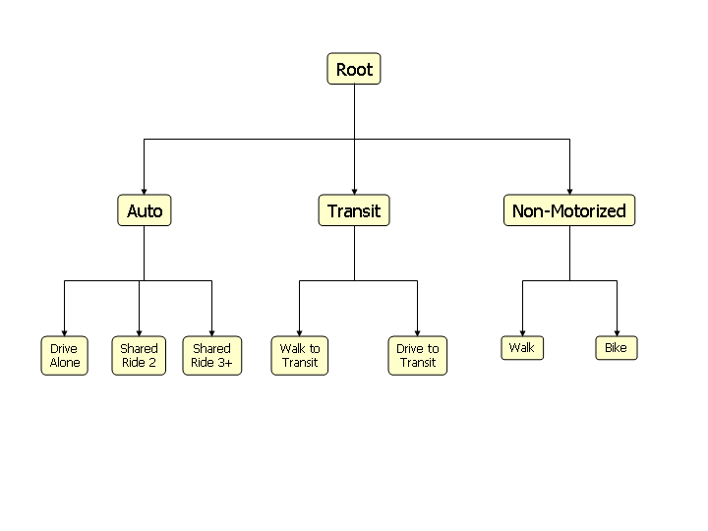

Figure 10. School Tour Mode Choice Model Structure

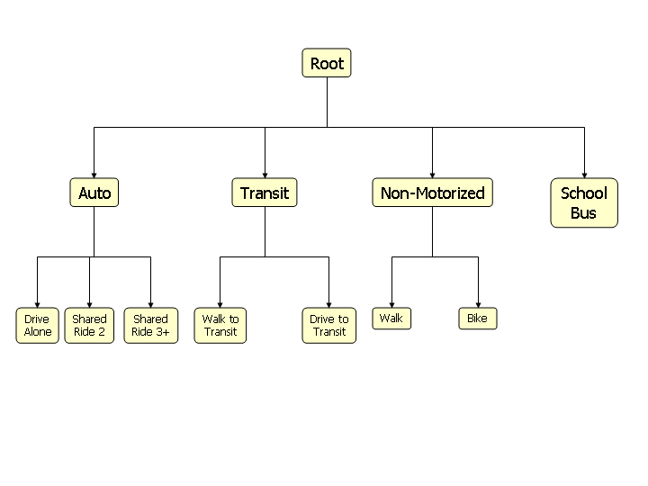

Figure 11. Other Tour Mode Choice Structure



Figure 12. Work-Based Subtour Mode Choice Structure

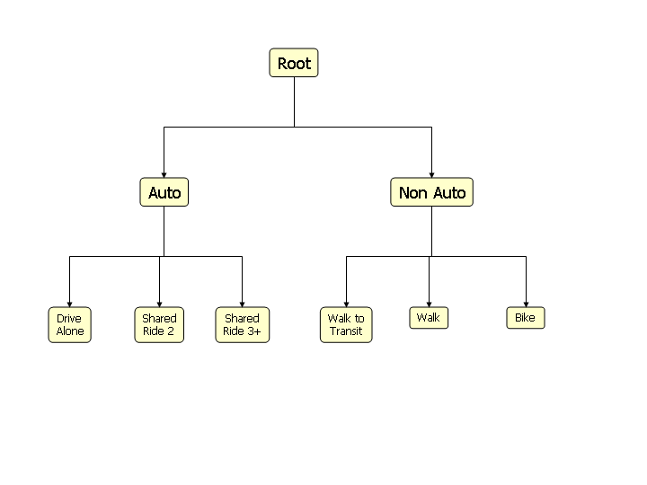

Table 13. Home Based Work Tour Mode Choice Model Variables

|  |  |  |
| --- | --- | --- |
|  | Coeff | T-stat |
| Cost($)- Low Income | -0.246 | -3.9 |
| Cost($)- Medium Income | -0.110 | -3.5 |
| Cost($)- High Income | -0.083 | -1.3 |
| Cost($)- Missing income | -0.103 | -0.8 |
| In-vehicle time (min) | -0.020 | constr |
| Transit walk time (min) | -0.050 | -10.8 |
| Transit first wait time (min,<=10) | -0.050 | -10.8 |
| Transit other wait time (min) | -0.030 | constr |
| Walk mode time (min) | -0.050 | -10.8 |
| Bike mode time (min) | -0.072 | -6.3 |
| Drive access time/total IVT | -1.433 | -4.5 |
| Local bus time/total transit IVT | -0.677 | -5.2 |
|  |  |  |
| SR2-constant | -2.889 | -27.9 |
| SR3-constant | -3.410 | -28.0 |
| BK-constant | -3.415 | -5.1 |
| WK-constant | -6.050 | -8.1 |
| WT-constant | -3.956 | -5.3 |
| DT-constant | -4.693 | -6.1 |
|  |  |  |
| DA,SR- Arrive at dest. in AM peak | -1.003 | -4.0 |
| DA,SR- Leave from dest. in PM peak | -0.268 | -1.3 |
| DA- Shopping stops/tours remaining | 0.847 | 5.6 |
|  |  |  |
| SR-No car in HH | 5.045 | 4.6 |
| SR-HH cars >0, <workers | 1.366 | 7.0 |
| SR-HH cars>=workers, <adults | 0.553 | 3.7 |
| SR-low income | 0.158 | 1.1 |
| SR-high income | -0.057 | -0.3 |
| SR-missing income | -0.215 | -0.4 |
| SR-female | 0.570 | 6.2 |
| SR-Escort stops/tours remaining | 5.391 | 26.5 |
| SR-Other stops/tours remaining | 0.495 | 8.5 |
| SR2-1 person HH | -1.659 | -7.0 |
| SR3-1 person HH | -2.452 | -6.8 |
| SR3-2 person HH | -1.704 | -9.3 |

Home based work (continued)

|  |  |  |
| --- | --- | --- |
|  | **Coeff** | **T-stat** |
| WT-No car in HH | 12.201 | 8.8 |
| WT-HH cars >0, <workers | 5.119 | 10.5 |
| WT-HH cars>=workers, <adults | 2.380 | 6.2 |
| WT-low income | 0.308 | 0.9 |
| WT-high income | -1.745 | -3.0 |
| WT-missing income | -0.782 | -1.4 |
| WT-origin intersection density | 6.800 | 2.6 |
| WT,DT-destination intersection density | 11.430 | 3.8 |
| WT,DT-destination retail density | 0.253 | 4.0 |
|  |  |  |
| DT-No car in HH | 9.260 | 5.9 |
| DT-HH cars >0, <workers | 3.529 | 6.2 |
| DT-HH cars>=workers, <adults | 1.572 | 3.6 |
| DT-low income | 0.043 | 0.1 |
| DT-high income | -1.215 | -2.1 |
| DT-missing income | -1.156 | -1.7 |
| DT-female | 0.656 | 3.3 |
|  |  |  |
| BK,WK-No car in HH | 9.810 | 7.1 |
| BK,WK-HH cars >0, <workers | 3.081 | 5.1 |
| BK,WK-HH cars>=workers, <adults | 1.556 | 2.7 |
| BK,WK-low income | 0.364 | 0.8 |
| BK,WK-high income | -1.526 | -1.9 |
| BK,WK-missing income | 0.467 | 0.7 |
| WK-age over 50 | -0.793 | -1.7 |
| WK-female | -0.761 | -1.8 |
| BK-female | -2.164 | -4.0 |
| WK-Origin,destination mixed use density | 0.742 | 2.9 |
| WK-Origin,destination intersection density | 8.628 | 3.2 |
| BK-Origin,destination retail density | 0.184 | 2.5 |
| BK-Origin,destination intersection density | 6.528 | 1.9 |
|  |  |  |
| Nesting parameter | 0.552 | 11.4 |
|  |  |  |
| Observations | 5266 | |
| Final log-likelihood | -3931.766 | |
| Rho-squared(0) | 0.5775 | |
| Rho-squared(const) | 0.3602 | |

Table 14. School Tour Mode Choice Variables

|  |  |  |
| --- | --- | --- |
|  | Coeff | T-stat |
| Cost ($) | -0.150 | -2.2 |
| In-vehicle time (min) | -0.010 | constr |
| Transit walk time (min) | -0.022 | -2.1 |
| Transit first wait time (min,<=10) | -0.020 | constr |
| Transit other wait time (min) | -0.020 | constr |
| Walk mode time (min) | -0.053 | -9.0 |
| Bike mode time (min) | -0.051 | -2.6 |
| Drive access time/total IVT | -2.136 | -2.5 |
| Local bus time/total transit IVT | -0.538 | -2.0 |
| Walk Mode Terminal Time | -0.022 | -2.1 |
|  |  |  |
| SR2-constant | -2.949 | -6.7 |
| SR3-constant | -2.380 | -5.3 |
| BK-constant | -1.382 | -2.9 |
| WK-constant | -4.700 | -8.0 |
| WT-constant | -4.494 | -4.9 |
| DT-constant | -3.990 | -3.7 |
| SB-constant | -3.104 | -6.2 |
|  |  |  |
| DA-Escort stops/tours remaining | -2.940 | -3.5 |
| DA-High school student age 16+ | -2.407 | -5.3 |
| DA-University student | -0.465 | -1.0 |
|  |  |  |
| SR-Escort stops/tours remaining | 1.500 | 4.9 |
| SR-Other stops/tours remaining | 0.366 | 3.9 |
| SR-Rural origin | -0.946 | -4.0 |
| SR-HH cars >0, <workers | 1.216 | 2.4 |
| SR-High income | -0.351 | -2.2 |
| SR-Missing income | -0.102 | -0.4 |
| SR3-1 person HH | -5.000 | constr |
| SR3-2 person HH | -2.067 | -5.7 |
|  |  |  |
| WT-No car in HH | 3.203 | 5.9 |
| WT-HH cars >0, <workers | 3.275 | 4.7 |
| WT-HH cars>=workers, <adults | 1.243 | 3.6 |
| WT,DT- Destination retail density | 0.162 | 1.5 |
| WT- Origin intersection density | 10.514 | 2.5 |
| WT,DT- Destination intersection density | 10.847 | 2.9 |
| WT,DT- Pre-school age | -2.724 | -2.0 |
| WT,DT- High school student age 16+ | 0.742 | 2.0 |
| WT,DT- University student | 2.299 | 5.3 |
| WT,DT- Other adult | 1.856 | 2.7 |

Home based school (continued)

|  |  |  |
| --- | --- | --- |
|  | Coeff | T-stat |
| BK,WK-No car in HH | 2.124 | 4.8 |
| BK,WK-HH cars >0, <workers | 1.535 | 2.4 |
| BK,WK-HH cars>=workers, <adults | 0.403 | 1.5 |
| WK- Pre-school age | -1.850 | -2.9 |
| WK- University student | 3.264 | 6.0 |
| WK- Other adult | 1.877 | 1.4 |
| WK- Origin/destination intersection density | 3.178 | 2.3 |
| WK- Rural origin | -2.031 | -2.4 |
| BK- Origin residential density | 0.198 | 2.1 |
| BK- CBD destination | 1.962 | 1.8 |
| BK- Pre-school age | -5.000 | constr |
| BK- High school student age 16+ | -2.000 | constr |
| BK- University student | 1.816 | 2.0 |
| BK-Female | -1.330 | -3.1 |
|  |  |  |
| SB- Pre-school age | -3.698 | -4.6 |
| SB- High school student age 16+ | -1.661 | -4.7 |
| SB-Full time worker | -10.000 | constr |
| SB-Part time worker | -10.000 | constr |
| SB-Adult non worker under age 65 | -10.000 | constr |
| SB-Retired non worker | -10.000 | constr |
| SB-University student | -10.000 | constr |
| SB- Distance(miles) | 0.097 | 3.0 |
| SB- Distance squared | -0.0073 | -3.3 |
| SB- Distance cubed | 0.00010 | 2.8 |
|  |  |  |
| Nesting parameter | 0.796 | 7.8 |
|  |  |  |
| Observations | 2295 | |
| Final log-likelihood | -2884.1943 | |
| Rho-squared(0) | 0.3236 | |
| Rho-squared(const) | 0.2081 | |

# 22. Tour Time of Day

#### Component Type: Multinomial Logit

Programming Language: C#

#### Inputs: tours table, persons table, skims, zones table

#### Outputs: tour time of day choice on the tours table

Given the known tour origin, destination and mode from previous models, the tour arrival and departure time model predicts the time arriving at the primary destination of the tour and the time leaving the primary destination, both to within 1 hour periods. There are 24 time periods in the model:

1. 4:00 AM- 4:59 AM

2. 5:00 AM- 5:59 AM

….

23. 1:00 AM – 1:59 AM

24. 3:00 AM – 3:59 AM

The departure period is always greater than or equal to the arrival period, and less than or equal to 24, so there are (24 + 23 + … + 2 + 1) alternatives, for a total of 300 alternatives.

The tour level mode choice models were estimated for the following tour purposes separately to represent the different characteristics of the time of day choice by purpose:

Home based work

Home based school

Home based other

Work based subtour

The main approach in the tour time of day models is to use constants for various groupings of arrival periods, departure periods and durations, plus shift effects that push arrivals earlier or later and durations of stay longer or shorter (as a result, shifting the departure period as well). This is the same basic approach used in the Columbus, Atlanta, and Sacramento models, as well as in the CS FHWA project on modeling time of day.

The models also make extensive use of the concept of available time windows for scheduling tours. As each tour is simulated, the periods that are used by the tour are made either fully or partially unavailable for any other tours, and the length of remaining time windows available during the day is calculated.

Finally, the tour time of day models are estimated and applied conditional on tour mode choice. For auto and transit tours, generalized time variables are used to estimate the effects of road congestion and transit scheduling on time of day choice. The weights on times and costs used to calculate the auto and transit generalized times are the same as were estimated for the tour mode choice models, keeping the two models as consistent as possible. Tours are modeled in priority order, as was specified in the tour priority assignment component.

and show the variables used in the work and other tour time of day choice models to serve as examples of the types of variables used in the tour time of day models.

Table 15. Home-Based Work Tour Time of Day Variables

| Variable description | Coeff | T-stat |
| --- | --- | --- |
| Arrival 0400 - 0559 constant | -0.6135 | -6.7 |
| Arrival 0600 - 0659 constant | 0.5324 | 9.0 |
| Arrival 0700 - 0759 constant | 0.5770 | 13.9 |
| Arrival 0800 - 0859 constant | 0.0000 | Constr |
| Arrival 0900 - 0959 constant | -1.2236 | -20.0 |
| Arrival 1000 - 1259 constant | -2.7947 | -32.1 |
| Arrival 1300 - 1559 constant | -4.0621 | -28.7 |
| Arrival 1600 -1859 constant | -5.4481 | -26.9 |
| Arrival 1900 - 2259 constant | -7.8594 | -24.1 |
| Arrival 2300 - 0359 constant | -10.2864 | -15.9 |
| Depart 0300 - 0559 constant | -10.0000 | Constr |
| Depart 0600 - 0959 constant | -1.9369 | -10.2 |
| Depart 1000 - 1259 constant | -0.4380 | -4.1 |
| Depart 1300 - 1559 constant | -0.2789 | -4.9 |
| Depart 1600 - 1659 constant | 0.0000 | Constr |
| Depart 1700 - 1759 constant | -0.0348 | -0.7 |
| Depart 1800 - 1859 constant | -0.9618 | -12.9 |
| Depart 1900 - 2059 constant | -2.1762 | -20.4 |
| Depart 2100 - 2359 constant | -2.5143 | -17.2 |
| Depart 2300 - 0359 constant | -4.0585 | -17.7 |
| Duration 0 - 259 constant | 0.7508 | 2.7 |
| Duration 300 - 459 constant | 1.2074 | 5.5 |
| Duration 500 - 659 constant | 1.1498 | 6.3 |
| Duration 700 - 859 constant | 0.8716 | 5.7 |
| Duration 900 - 959 constant | 0.0000 | Constr |
| Duration 1000 - 1059 constant | -0.8319 | -14.4 |
| Duration 1100 - 1159 constant | -1.7328 | -18.2 |
| Duration 1200 - 1359 constant | -2.9350 | -20.4 |
| Duration 1400 - 1759 constant | -6.5169 | -20.0 |
| Duration 1800 - 2359 constant | -10.0000 | Constr |
| Part-time worker-Arrival shift | 0.0401 | 2.3 |
| Part-time worker-Duration shift | -0.1702 | -6.5 |
| Other non-worker -Arrival shift | -0.0357 | -0.5 |
| Other non-worker -Duration shift | -0.3018 | -3.3 |
| Child Age 5-15 – Arrival shift 0.618  Child Age 5-15- Duration shift | 0.588 |  |
| PartTimeWorker Arrival 1300-1559 0.112  University student -Arrival shift | 0.3582 | 9.7 |
| University student-Duration shift | 0.4708 | 8.5 |
| K12 student 16+ -Arrival shift | 0.5449 | 11.5 |
| K12 student 16+ -Duration shift | 0.5231 | 8.2 |
| Full-time worker - Duration < 9 hrs | -1.4685 | -9.6 |
| Income <$25K - Arrival shift | 0.0240 | 1.3 |
| Income <$25K - Duration shift | -0.0227 | -1.0 |
| Income >$75K - Arrival shift | -0.0016 | -0.1 |
| Income >$75K - Duration shift | 0.0250 | 1.6 |
| Income>$75K - Departure before 0600 | -0.5203 | -5.9 |
| Income >$75K - Arrival after 2200 | -0.3562 | -1.9 |
| # stop purposes/only tour - Arrival shift | -0.0221 | -2.6 |
| # stop purposes/only tour - Duration shift | -0.2220 | -22.9 |
| # stop purposes/multiple tours - Arrival shift | -0.0086 | -1.2 |
| # stop purposes/multiple tours - Duration shift | -0.1544 | -16.1 |
| Escort stops in day - Arrival shift | -0.0086 | -0.5 |
| Escort stops in day - Duration shift | 0.1450 | 7.5 |
| Only tour in day - Arrival shift | 0.0194 | 1.0 |
| Only tour in day - Duration shift | 0.2165 | 6.3 |
| # subtours in tour - Arrival shift | -0.0739 | -4.2 |
| # subtours in tour - Duration shift | 0.1252 | 7.2 |
| Lower of 2+ work tours - Arrival shift | 0.5267 | 17.1 |
| Lower of 2+ work tours - Duration shift | 0.3037 | 5.6 |
| Higher of 2+ work tours- Duration<8 hrs | 1.5578 | 8.0 |
| Lower of 2+ work tours- Duration<8 hrs | 2.7790 | 2.7 |
| Higher of 2+ different tours - Duration<8 hrs | -0.5765 | -5.6 |
| Lower of 2+ different tours- Duration<8 hrs | 0.0750 | 0.2 |
| Arrival period partially used | -2.5090 | -7.4 |
| Departure period partially used | -2.0687 | -6.7 |
| Empty window remaining before- 1st tour | 0.0830 | 1.8 |
| Empty window remaining after - 1st tour | -0.4566 | -10.0 |
| Empty window remaining before- 2nd+ tour | 0.0647 | 1.2 |
| Empty window remaining after - 2nd+ tour | 0.0067 | 0.2 |
| Remaining tours/total remaining window | -24.77 | -4.6 |
| Remaining tours/maximum remaining window | -3.7935 | -2.0 |
| Auto generalized time (min)- Full-time worker | -0.0060 | Constr |
| Auto generalized time (min)- Part-time worker | -0.0404 | -2.8 |
| Auto generalized time (min)- Other person type | -0.0326 | -1.0 |
| Transit generalized time (min)- Transit tours | -0.0058 | -1.9 |
| Observations | 5238 | |
| Final log-likelihood | -21210.2 | |
| Rho-squared(0) | 0.2935 | |
| Rho-squared(const) | 0.0469 | |
|  |  | |

Table 16. Home Based Other Tour Time of Day Choice Variables

| Variable description | Coeff | T-stat |
| --- | --- | --- |
| Arrival 0400 - 0559 constant | -0.6135 | -6.7 |
| Arrival 0600 - 0659 constant | 0.5324 | 9.0 |
| Arrival 0700 - 0759 constant | 0.5770 | 13.9 |
| Arrival 0800 - 0859 constant | 0.0000 | Constr |
| Arrival 0900 - 0959 constant | -1.2236 | -20.0 |
| Arrival 1000 - 1259 constant | -2.7947 | -32.1 |
| Arrival 1300 - 1559 constant | -4.0621 | -28.7 |
| Arrival 1600 -1859 constant | -5.4481 | -26.9 |
| Arrival 1900 - 2259 constant | -7.8594 | -24.1 |
| Arrival 2300 - 0359 constant | -10.2864 | -15.9 |
| Depart 0300 - 0559 constant | -10.0000 | Constr |
| Depart 0600 - 0959 constant | -1.9369 | -10.2 |
| Depart 1000 - 1259 constant | -0.4380 | -4.1 |
| Depart 1300 - 1559 constant | -0.2789 | -4.9 |
| Depart 1600 - 1659 constant | 0.0000 | Constr |
| Depart 1700 - 1759 constant | -0.0348 | -0.7 |
| Depart 1800 - 1859 constant | -0.9618 | -12.9 |
| Depart 1900 - 2059 constant | -2.1762 | -20.4 |
| Depart 2100 - 2359 constant | -2.5143 | -17.2 |
| Depart 2300 - 0359 constant | -4.0585 | -17.7 |
| Duration 0 - 259 constant | 0.7508 | 2.7 |
| Duration 300 - 459 constant | 1.2074 | 5.5 |
| Duration 500 - 659 constant | 1.1498 | 6.3 |
| Duration 700 - 859 constant | 0.8716 | 5.7 |
| Duration 900 - 959 constant | 0.0000 | Constr |
| Duration 1000 - 1059 constant | -0.8319 | -14.4 |
| Duration 1100 - 1159 constant | -1.7328 | -18.2 |
| Duration 1200 - 1359 constant | -2.9350 | -20.4 |
| Duration 1400 - 1759 constant | -6.5169 | -20.0 |
| Duration 1800 - 2359 constant | -10.0000 | Constr |
| Part-time worker-Arrival shift | 0.0401 | 2.3 |
| Part-time worker-Duration shift | -0.1702 | -6.5 |
| Other non-worker -Arrival shift | -0.0357 | -0.5 |
| Other non-worker -Duration shift | -0.3018 | -3.3 |
| Child Age 5-15 – Arrival shift 0.618  Child Age 5-15- Duration shift | 0.588 |  |
| PartTimeWorker Arrival 1300-1559 0.112  University student -Arrival shift | 0.3582 | 9.7 |
| University student-Duration shift | 0.4708 | 8.5 |
| K12 student 16+ -Arrival shift | 0.5449 | 11.5 |
| K12 student 16+ -Duration shift | 0.5231 | 8.2 |
| Full-time worker - Duration < 9 hrs | -1.4685 | -9.6 |
| Income <$25K - Arrival shift | 0.0240 | 1.3 |
| Income <$25K - Duration shift | -0.0227 | -1.0 |
| Income >$75K - Arrival shift | -0.0016 | -0.1 |
| Income >$75K - Duration shift | 0.0250 | 1.6 |
| Income>$75K - Departure before 0600 | -0.5203 | -5.9 |
| Income >$75K - Arrival after 2200 | -0.3562 | -1.9 |
| # stop purposes/only tour - Arrival shift | -0.0221 | -2.6 |
| # stop purposes/only tour - Duration shift | -0.2220 | -22.9 |
| # stop purposes/multiple tours - Arrival shift | -0.0086 | -1.2 |
| # stop purposes/multiple tours - Duration shift | -0.1544 | -16.1 |
| Escort stops in day - Arrival shift | -0.0086 | -0.5 |
| Escort stops in day - Duration shift | 0.1450 | 7.5 |
| Only tour in day - Arrival shift | 0.0194 | 1.0 |
| Only tour in day - Duration shift | 0.2165 | 6.3 |
| # subtours in tour - Arrival shift | -0.0739 | -4.2 |
| # subtours in tour - Duration shift | 0.1252 | 7.2 |
| Lower of 2+ work tours - Arrival shift | 0.5267 | 17.1 |
| Lower of 2+ work tours - Duration shift | 0.3037 | 5.6 |
| Higher of 2+ work tours- Duration<8 hrs | 1.5578 | 8.0 |
| Lower of 2+ work tours- Duration<8 hrs | 2.7790 | 2.7 |
| Higher of 2+ different tours - Duration<8 hrs | -0.5765 | -5.6 |
| Lower of 2+ different tours- Duration<8 hrs | 0.0750 | 0.2 |
| Arrival period partially used | -2.5090 | -7.4 |
| Departure period partially used | -2.0687 | -6.7 |
| Empty window remaining before- 1st tour | 0.0830 | 1.8 |
| Empty window remaining after - 1st tour | -0.4566 | -10.0 |
| Empty window remaining before- 2nd+ tour | 0.0647 | 1.2 |
| Empty window remaining after - 2nd+ tour | 0.0067 | 0.2 |
| Remaining tours/total remaining window | -24.77 | -4.6 |
| Remaining tours/maximum remaining window | -3.7935 | -2.0 |
| Auto generalized time (min)- Full-time worker | -0.0060 | Constr |
| Auto generalized time (min)- Part-time worker | -0.0404 | -2.8 |
| Auto generalized time (min)- Other person type | -0.0326 | -1.0 |
| Transit generalized time (min)- Transit tours | -0.0058 | -1.9 |
| Observations | 5238 | |
| Final log-likelihood | -21210.2 | |
| Rho-squared(0) | 0.2935 | |
| Rho-squared(const) | 0.0469 | |
|  |  | |

# 23. Intermediate Stop Generation

#### Component Type: Multinomial Logit

Programming Language: C#

#### Inputs: tours table, persons table, skims, zones table

#### Outputs: trips table created, half tour stops inserted for intermediate stops

After the tour-level models are run, a series of trip-level models are run. The first trip level model is the intermediate stop generation model which generates intermediate stops. The intermediate stop generation model is a multinomial logit model applied to each half tour in an individual’s daily activity pattern that includes at least one stop. A half tour is defined as the portion of a tour from the home to the primary destination, or the portion from the primary destination back to the home, in either case including all stops. Therefore each tour can be divided into exactly two half tours. Whether there is at least one stop is determined from the day pattern model.

The model has eight alternatives, including seven possible stop purposes: work, school, escort, personal business, shopping, meal and social/recreational (the same purposes for home based tours in the day pattern model) plus a “quit” alternative meaning that there are no further stops. If the application results in the choice of a stop for one of the seven purposes (i.e., the choice is not the “quit” alternative), the model is applied again to obtain the choice of whether to make a second stop and, if so, the purpose of that stop. This process continues until the “quit” alternative is chosen or until the maximum number of six stops is reached.

The choice of stop purpose or to “quit” is a function of some household and person characteristics, as well as information about the tour/half tour, including the distance between the home and primary destination, the tour purpose, whether it is outbound (from the tour origin, which is the home, unless the tour being simulated is a work based subtour, in which case the tour origin is the workplace) or inbound, and the tour mode. Also included in the model are characteristics of the stop itself, including the time of day, whether the stop is for the same purpose as the current tour or a prior tour, and whether the stop is the first simulated in the tour. The number of tours remaining to be simulated and the time window available after the tours have been scheduled are also included in the model.

The availability of each of the seven stop purposes is dependent on whether there is at least one stop of that purpose predicted by the day pattern model. This availability is achieved by adding highly negative terms to the utility function where a stop of that purpose is NOT predicted by the daily activity pattern for the person whose half tour is being operated upon. So for example, for the Work Stop purpose, a term -50000*NoWorkStop makes work stops unavailable for daily activity patterns that have no work stops on them. Work stops are available only for home based work tours, home based school tours, and work based subtours. School stops are available only for home based work and home based school tours. Escort stops are available only for home based work tours, home based school tours, home based escort tours, and work based subtours. This availability is achieved by adding highly negative terms to the utility functions for the purposes on which a stop is not allowed for a tour of that purpose. For example, for the work stop choice, a term -50000*HomeBasedPersonalBusinessTour is added to effectively make the choice unavailable. The “quit” alternative is always available.

The stops are simulated in order from the primary destination towards the tour origin (the home or, in the case of work based subtours, the workplace). This means that stops on the outbound half tour are predicted in reverse chronological order.

When creating trips, on the first tour half, the purpose of the trip is the purpose associated with the trip destination.  On the second tour half, the purpose of the trip is the purpose associated with the trip origin.

shows the variables used for the utility of work, school, escort and personal business stops and the quit alternative.

Table 17. Intermediate Stop Generation Variables for Work, School, Escort and Personal Business

|  |  |  |  |  |  |  |  |  |
| --- | --- | --- | --- | --- | --- | --- | --- | --- |
| **Stop purpose** | **Work** |  | **School** |  | **Escort** |  | **PerBus** |  |
|  | **Coef** | **T-stat** | **Coef** | **T-stat** | **Coef** | **T-stat** | **Coef** | **T-stat** |
| Work-based subtour | -5.4006 | -19.7 | -50000 |  | -1.1358 | -4.0 | 0.2768 | 2.0 |
| HB Work tour | -2.0394 | -7.0 | 3.1438 | 6.6 | 0.5021 | 2.5 | 1.1878 | 8.4 |
| HB School tour | -2.7946 | -7.9 | 3.4563 | 7.5 | -0.0809 | -0.4 | 1.0665 | 7.0 |
| HB Escort tour | -50000 |  | -50000 |  | -0.6965 | -3.2 | 1.3431 | 8.5 |
| HB Personal bus. tour | -5000 |  | -50000 |  | -50000 |  | 1.0935 | 7.3 |
| HB Shopping tour | -50000 |  | -50000 |  | -50000 |  | 1.1517 | 7.8 |
| HB Meal tour | -50000 |  | -50000 |  | -50000 |  | 1.0613 | 5.7 |
| HB Social/recreation tour | -50000 |  | -50000 |  | -50000 |  | 0.7609 | 4.7 |
| No Stop of This Purpose | -50000 |  | -50000 |  | -500000 |  | -50000 |  |
| Outbound half tour | -0.0449 | -0.4 | -1.1873 | -4.8 | -0.6001 | -6.4 | -0.3606 | -5.7 |
| Stop for same purpose- prior tours | 0.4558 | 6.6 | -10.0000 | * | -1.0180 | -10.8 | -1.5972 | -20.5 |
| Stops for same purpose- same tour | -0.1665 | -3.5 | -3.7775 | -12.8 | -1.4046 | -24.0 | -1.1578 | -24.2 |
| Tours remaining in the day | -0.4443 | -7.0 | -0.4165 | -2.7 | -0.2944 | -8.2 | -0.6515 | -18.6 |
| Time window available (hours) | 0.2207 | 15.7 |  |  | 0.0849 | 8.6 | 0.0826 | 12.0 |
| LN of tour OD distance | 0.1909 | 5.5 | 0.2133 | 2.4 | 0.1002 | 4.6 | 0.1107 | 6.0 |
|  |  |  |  |  |  |  |  |  |
| Period 7 am to 9 am | -2.0782 | -11.4 | -2.2828 | -5.9 | 0.3413 | 4.2 | -0.9310 | -11.0 |
| Period 9 am to 11 am | -0.2453 | -1.9 |  |  |  |  |  |  |
| Period 3 pm to 5 pm | -0.5605 | -4.7 |  |  | 0.1919 | 2.5 | -0.1137 | -1.8 |
| Period 5 pm to 7 pm | -1.7399 | -9.6 | -1.0912 | -2.2 |  |  | -0.5321 | -6.7 |
| Period 7 pm to 10 pm | -1.7792 | -5.6 | -10.0000 | * |  |  | -0.8647 | -8.0 |
| Period 10 pm to 7 am | -2.6096 | -7.5 | -10.0000 | * |  |  | -1.9709 | -8.6 |
|  |  |  |  |  |  |  |  |  |
| Part time worker |  |  |  |  |  |  |  |  |
| University student |  |  | -0.9600 | -2.7 |  |  |  |  |
| Non-worker age 65+ | -0.7492 | -2.0 |  |  |  |  |  |  |
| Non-workers age 18-65 |  |  |  |  | 0.5895 | 2.9 | -0.2259 | -2.7 |
| Driving age student |  |  |  |  |  |  |  |  |
| Child age under 5 |  |  |  |  |  |  |  |  |
| Child age 5-15 |  |  |  |  |  |  |  |  |
| Female adult, children in HH |  |  |  |  | 0.2223 | 3.4 |  |  |
| Tour mode is drive alone | 0.3650 | 3.0 |  |  | -1.9476 | -8.4 |  |  |
| Tour mode is shared ride 2 | 0.4558 | 3.3 |  |  | 0.2203 | 1.7 |  |  |
| Tour mode is shared ride 3+ | 0.3701 | 2.2 |  |  | 0.8234 | 6.6 |  |  |
| Single person household |  |  |  |  |  |  | 0.1226 | 1.8 |
| Trip is first simulated in half tour | 1.6671 | 16.5 | -1.1297 | 16.5 |  |  |  |  |

|  |  |  |
| --- | --- | --- |
| **Additional variables** | **Quit** |  |
|  | **Coef** | **T-stat** |
| Trip 2 on outbound half tour | 0.1547 | 2.9 |
| Trip 3 on outbound half tour | 0.0085 | 0.1 |
| Trip 4 on outbound half tour | -0.0812 | -0.6 |
| Trip 5 on outbound half tour | -0.1757 | -0.9 |
| Trip 6 on outbound half tour | -0.4087 | -1.4 |
| Trip 2 on return half tour | 0.6711 | 15.0 |
| Trip 3 on return half tour | 0.8087 | 12.7 |
| Trip 4 on return half tour | 0.7960 | 8.3 |
| Trip 5 on return half tour | 0.5595 | 3.9 |
| Trip 6 on return half tour | 0.5767 | 2.7 |
| HB work tour with subtour(s) | 0.8696 | 16.7 |
| HB secondary tour | -0.1742 | -3.7 |

|  |  |
| --- | --- |
| Observations | 32598 |
| Final log-likelihood | -22902.7 |
| Rho-squared (0) | 0.313 |
| Rho-squared (const) | 0.224 |

# 24. Trip Time of Day Simulation

#### Component Type: Monte Carlo Simulation

Programming Language: C#

#### Inputs: observed intermediate stop times of day from the TBI, tours table

#### Outputs: intermediate stop times assigned to the half-tour stops table

The trip time of day simulation is run after all trips have been created by the intermediate stop generation model. The simulation selects the arrival time for stops made on the half tour from home to the primary activity (outbound) and the departure time for stops made on the half tour from the primary activity to home (inbound). There are 24 potential alternatives in the model representing 1-hour time periods:

1. 4:00 a.m. –4 :59 a.m.

2. 5:00 a.m. - 5:59 a.m.

….

23. 1:00 a.m. – 1:59 a.m.

24. 3:00 a.m. – 3:59 a.m.

The probabilities for arriving or departing intermediate stop locations for each of the 24 hour periods is based on the observed weighted number of intermediate stops in each period in the TBI. More specifically, the probability for each time period and purpose equals the sum of the weights for intermediate stops that had this time period and purpose divided by the sum of all weights for this purpose.

Operationally the trip time of day model runs by dividing the trips into groups by purpose. Then the monte carlo simulation will use the probabilities dependent on purpose, as shown on the TripTimeofDayAlts table to assign a choice of a one hour period for the stop to be arrived at or departed from.

# 25. Trip Time Copier

#### Component Type: Special

Programming Language: C#

#### Inputs: half tour stop times

#### Outputs: trip time hour periods on the trips table

Each trip needs to have a time of day associated with it to determine which time-of-day skims to use in the intermediate stop location and trip mode choice model. This simple component takes the times from the half-tour stops tables and copies them over to the trips table. For trips on the outbound (away from home) half-tour, the time is copied from the associated half-tour stop that is trip destination. For trips on the inbound (towards home) half-tour, the time is copied from the associated half-tour stop that is the trip origin.

# 26. Intermediate Stop Location

#### Component Type: Multinomial Logit

Programming Language: C#

#### Inputs: tours table, zones table, generalized time skims, persons table

#### Outputs: intermediate stops given zones and points on the half-tour stops and trips tables.

The intermediate stop location choice model is a multinomial logit model that select the zones for each intermediate stop. The locations of all intermediate stops on tours are modeled one at a time, first for stops made on the half tour from home to the primary activity (outbound) and then for stops made on the half tour from the primary activity to home (inbound).

At the time that a particular stop’s location is modeled, information about the tour (origin, destination, time period arriving and departing the primary destination, and tour mode are known and can be used to explain the location choice. The number of stops in each half-tour and their purposes are known.

However, at the time a stop’s destination is modeled, several important items are NOT known. These include the trip mode for the trip between this stop and the stop nearer to the tour destination, and the departure and arrival times of that trip, which will be modeled after this stop’s location.

As a result of this modeling approach, two known locations serve as anchor points for calculating travel impedance. These are the stop locations immediately toward the tour destination (the tour destination itself for the first stop in a half-tour), which is called the stop origin, and the tour origin. Furthermore, when calculating impedance, the mode used is the known tour mode, instead of the trip mode.

The intermediate stop location choice model is essentially the same for all stop purposes, with the exception of the zonal size variables which vary across the purposes. shows the variables used in the intermediate stop location choice model.

Table 18. Intermediate Stop Location Choice Variables

|  |  |  |
| --- | --- | --- |
|  | **Coeff** | **T-stat** |
| Generalized time | -0.0349 | -33.5 |
|  |  |  |
| Destination mixed use density | 0.0017 | 6.9 |
| Rural dummy | 0.1029 | 0.7 |
|  |  |  |
| Base for log size multiplier | 1.000 | constr |
| Number of households | 0.9624 | 3.9 |
| Total employment | 1.1608 | 5.2 |
| Observations | 1,184 | |
| Final log-likelihood | -8048.89 | |
| Rho-squared(0) | 0.312 | |
| Rho-squared(const) | 0.768 | |

# 27. Trip Mode Choice

#### Component Type: Multinomial Logit

Programming Language: C#

#### Inputs: tours table, zones table, generalized time skims, persons table

#### Outputs: intermediate stops given zones and points on the half-tour stops and trips tables.

The trip mode choice model determines the trip mode on all trips, including half-tours with no stops. The tour mode has already been found by the tour mode choice model, and this knowledge is used in combination with skim data, zonal data, and person data to find the trip modes on these tours.

A single multinomial logit model was estimated to be used for all tour and trip purposes, with some purpose specific dummy variables used to develop different utilities for different tour and trip purpose combinations. The mode alternatives for the model by purpose are:

Home based work (drive alone, shared ride 2, shared ride 3+, walk, bike, walk to transit, drive to transit)

Home based school (drive alone, shared ride 2, shared ride 3+, walk, bike, walk to transit, drive to transit, school bus)

Home based escort (shared ride 2, shared ride 3+, walk)

Home based other (drive alone, shared ride 2, shared ride 3+, walk, bike, walk to transit, drive to transit)

Work based subtour (drive alone, shared ride 2, shared ride 3+, walk, bike, walk to transit)

The modes available for a particular trip are based on the mode for the tour of which the trip is part. Mode availability is shown in Table 19. This table also shows the number of observations in the model estimation data set for each tour mode-trip mode combination.

Table . Trip Mode Availability By Tour Mode

|  |  |  |  |  |  |  |  |  |  |
| --- | --- | --- | --- | --- | --- | --- | --- | --- | --- |
|  | | Tour Mode | | | | | | | |
| DT | WT | SB | SR3+ | SR2 | DA | B | W |
| Trip mode | DT | X |  |  |  |  |  |  |  |
| WT | X | X |  |  |  |  |  |  |
| SB | X | X | X |  |  |  |  |  |
| SR3+ | X | X | X | X |  |  |  |  |
| SR2 | X | X | X | X | X |  |  |  |
| DA | X | X | X | X | X | X |  |  |
| B | X | X | X | X | X | X | X |  |
| W | X | X | X | X | X | X | X | X |

|  |  |  |  |  |  |  |  |  |  |
| --- | --- | --- | --- | --- | --- | --- | --- | --- | --- |
|  | | Tour Mode | | | | | | | |
| DT | WT | SB | SR3+ | SR2 | DA | B | W |
| Trip mode | DT | 476 |  |  |  |  |  |  |  |
| WT | 41 | 1648 |  |  |  |  |  |  |
| SB | - | 4 | 873 |  |  |  |  |  |
| SR3+ | 15 | 59 | 225 | 6753 |  |  |  |  |
| SR2 | 64 | 174 | 141 | 1647 | 8516 |  |  |  |
| DA | 56 | 47 | 12X | 1227 | 3041 | 16539 |  |  |
| B | - | 3 | 5 | 7 | 11 | 8 | 307 |  |
| W | 44 | 253 | 74 | 174 | 250 | 182 | 8 | 2494 |

Key:

WT Drive to transit

DT Walk to transit

SB School bus

SR3+ Shared ride 3+

SR2 Shared ride 2

DA Drive alone

B Bike

W Walk

The intermediate stop location choice model is a multinomial logit model that select the zones for

Table . Trip Mode Choice Variables

|  |  |  |
| --- | --- | --- |
|  | **Coeff** | **T-stat** |
| Generalized Time | -0.0132 | -25.6 |
| DT – Constant | 0.489 | 2.1 |
| DT – HH cars >0, <drivers | -0.142 | -0.6 |
| DT – Missing Income | 1.69 | 2.0 |
| DT – High Income | 0.450 | 1.7 |
| WT – Constant | -0.734 | -4.6 |
| WT– HH cars >0, <workers | 0.740 | 5.7 |
| SR3 – constant | 3.40 | 24.8 |
| SR3 – 1 person HH | -1.19 | -7.1 |
| SR3 – 2 person HH | -0.928 | -10.9 |
| SR2 – 1 person HH | -0.962 | -8.9 |
| SR2 – constant | 0.358 | 2.9 |
| SR – No car in HH | -0.601 | -4.6 |
| SR – High Income | -0.0481 | -0.9 |
| SR – Missing Income | -0.271 | -2.0 |
| SR – Household Members age 5-15 | -0.269 | -14.0 |
| SR – Household nonworking adults | 0.126 | 3.8 |
| SR – Work Tour | -0.889 | -15.2 |
| SR – School Tour | -0.513 | -6.1 |
| SR – Escort Tour | 1.29 | 5.4 |
| SR – Shop Tour | 1.68 | 14.1 |
| SR – Meal Tour | 1.50 | 10.1 |
| SR – Social/Recreation Tour | 0.888 | 9.2 |
| DA – constant | 1.32 | 15.0 |
| DA – HH cars >0, <drivers | -0.429 | -7.3 |
| DA – Low Income | -0.247 | -2.5 |
| DA – Low-med Income | -0.178 | -2.8 |
| DA – Missing Income | -0.656 | -4.4 |
| B – Constant | -1.29 | -4.9 |
| B – Male | 0.863 | 3.5 |
| B – Work Based tour | -0.739 | -2.1 |
| B – Origin intersection density | 5.39 | 1.8 |
| W – Age under 35 | 0.623 | 6.4 |
| W – Origin intersection density | 3.30 | 3.4 |
| W – Destination intersection density | 0.729 | 6.5 |
| W – Work Tour | -0.603 | -5.8 |
| W – School Tour | 1.01 | 8.2 |

|  |  |  |
| --- | --- | --- |
|  | **Coeff** | **T-stat** |
| Transit – Origin Intersection Density | 1.31 | 1.1 |
| Transit – Destination Mixed Density | 0.443 | 3.3 |
| All – Same as tour mode | 1.40 | 15.0 |
| All – same as tour mode – only outbound trip | 1.53 | 18.8 |
| All – same as tour mode – only return trip | 1.60 | 18.9 |
| All – same as tour mode – first outbound trip | 0.273 | 2.7 |
| All – same as tour mode – first return trip | 0.105 | 1.3 |
| All – same as tour mode – last outbound trip | 0.231 | 2.4 |
| All – same as tour mode – last return trip | 0.127 | 1.5 |
| SB – WT Tour | -3.84 | -7.4 |
| SR3 – DT Tour | -6.50 | -19.5 |
| SR3 – WT Tour | -5.26 | -26.6 |
| SR3 – SB Tour | -1.10 | -7.3 |
| SR2 – WT Tour | -1.38 | -8.1 |
| SR2 – SB Tour | 1.44 | 7.6 |
| SR2 – SR3 Tour | 1.52 | 10.2 |
| DA – DT Tour | -1.49 | -8.5 |
| DA – WT Tour | -3.59 | -19.2 |
| DA – SR3 Tour | 0.764 | 6.2 |
| B – WT Tour | -4.22 | -6.9 |
| B – SR3 Tour | -2.30 | -5.5 |
| B – SR2 Tour | -3.16 | -8.1 |
| B – DA Tour | -3.30 | -7.9 |
| SR – escort to work trip / am peak period | -2.10 | -13.1 |
| SR – work to escort trip / pm peak period | -1.45 | -9.6 |
| SR – home to escort trip / am peak period | 2.36 | 14.6 |
| SR – home to escort trip / midday period | 1.32 | 3.8 |
| SR – home to escort trip / pm peak period | 0.747 | 1.4 |
| SR – home to escort trip / evening period | -0.663 | -1.0 |
| SR – escort to home trip / midday period | 0.268 | 1.0 |
| SR – escort to home trip / pm peak period | 1.67 | 9.4 |
| SR – escort to home trip / evening period | -1.25 | -1.6 |

# 28. Trip Time of Day

#### Component Type: Multinomial Logit

Programming Language: C#

#### Inputs: trips table, generalized time skims, persons table

#### Outputs: trips table updated with time of day choice

Given the origin, destination and mode of each trip, the trip time of day choice model predicts the arrival time for stops made on the half tour from home to the primary activity (outbound) and the departure time for stops made on the half tour from the primary activity to home (inbound). There are 24 potential alternatives in the model representing 1-hour time periods:

1. 4:00 a.m. –4 :59 a.m.

2. 5:00 a.m. - 5:59 a.m.

….

23. 1:00 a.m. – 1:59 a.m.

24. 3:00 a.m. – 3:59 a.m.

The time period alternatives available for each stop are constrained by the time window for the primary activity, as determined by the tour time of day choice model, and the half tour on which the stop occurs. For example, if the primary activity of the tour occurs between 8:00 p.m. and 11:00 p.m., and the stop is on the outbound half tour, the alternatives available are 1 (3:00 a.m. – 3:59 a.m) through 18 (8:00 p.m. – 8:59 p.m.), assuming no other stops on that half tour have been previously simulated.

If other tours have previously been simulated, then the time windows for those tours are unavailable. Following the example above, if there had been a previously simulated tour that spanned the 8:00 a.m. to 5:00 p.m. window (including travel times), then the alternatives available for a stop on the outbound half tour would be 15 (5:00 p.m. – 5:59 p.m) through 18 (8:00 p.m. – 8:59 p.m.).

On the outbound half tour, the arrival times for stops are simulated backwards in time, from the primary destination toward home (i.e. from the latest stop on the outbound half tour to the earliest). For those cases, the departure time from the stop currently being simulated is already known; it is the arrival time at the next stop on the tour, which is the stop most recently simulated (or the primary destination, for the first/latest stop being simulated on the outbound half tour) minus the travel time from the stop currently being simulated to the next stop on the tour. Note that this travel time is known from the network skims since all stop locations (from the trip destination choice model) and modes (from the trip mode choice model) are known from previously applied models. With the departure time from the stop already known, and the arrival time simulated by the trip time of day choice model, the activity duration for the stop can be inferred (roughly, given the one-hour time periods) as the difference between the arrival and departure times.

On the inbound half tour, the departure times for stops are simulated forward in time from the primary destination toward home (i.e. from the earliest stop on the inbound half tour to the latest). For those cases, the arrival time from the stop currently being simulated is already known; it is the departure time at the previous stop on the tour, which is the stop most recently simulated (or the primary destination, for the first/earliest stop being simulated on the inbound half tour) plus the travel time from the stop currently being simulated to the previous stop on the tour. Again, this travel time is known from the network skims since all stop locations (from the trip destination choice model) and modes (from the trip mode choice model) are known from previously applied models. With the arrival time at the stop already known, and the departure time simulated by the trip time of day choice model, the activity duration for the stop can be inferred (roughly, given the one-hour time periods) as the difference between the arrival and departure times.

These rules regarding the simulation ordering of stops further constrain the available alternatives for each stop. For the outbound half tour, the available alternatives are alternative 1 (3:00 a.m. – 3:59 a.m.), or the ending period of the latest tour occurring before the current tour that has been already simulated, through the period representing the departure time from the stop. For example, if the departure time at the stop is alternative 5 (7:00 a.m. – 7:59 a.m.), and no earlier tours have been previously simulated, the available alternatives are 1 through 5. For the inbound half tour, the available alternatives are the period representing the arrival time at the stop through alternative 24 (2:00 a.m. – 2:59 a.m.), or the starting period of the earliest tour occurring after the current tour that has been already simulated. For example, if the arrival time at the stop is alternative 17 (7:00 p.m. – 7:59 p.m.), and no earlier tours have been previously simulated, the available alternatives are 17 through 24.

The variables in the trip time of day choice model are generalized time, scheduling and person variables. shows the variables and coefficients used in the trip time of day model.

Table . Trip Time of Day Model Variables

|  |  |  |  |
| --- | --- | --- | --- |
| **Coef #** | **Variable description** | **Estimate** | **T-stat** |
| 11 | Arrival 0400 - 0559 constant | 0.2006 | 1.6 |
| 12 | Arrival 0600 - 0659 constant | -2.1397 | -14.7 |
| 13 | Arrival 0700 - 0759 constant | -0.8816 | -8.5 |
| 14 | Arrival 0800 - 0859 constant | 0.0000 | Constr |
| 15 | Arrival 0900 - 0959 constant | 0.3687 | 3.7 |
| 16 | Arrival 1000 - 1259 constant | 1.6431 | 14.6 |
| 17 | Arrival 1300 - 1559 constant | 3.5090 | 18.9 |
| 18 | Arrival 1600 -1859 constant | 4.6715 | 17.9 |
| 19 | Arrival 1900 - 2159 constant | 5.0037 | 11.4 |
| 20 | Arrival 2200 - 0359 constant | 8.3481 | 7.2 |
| 21 | Depart 0400 - 0659 constant | -1.3801 | -1.4 |
| 22 | Depart 0700 - 0959 constant | -0.8793 | -4.4 |
| 23 | Depart 1000 - 1259 constant | -0.3545 | -2.9 |
| 24 | Depart 1300 - 1559 constant | -0.2725 | -4.3 |
| 25 | Depart 1600 - 1659 constant | 0.0000 | Constr |
| 26 | Depart 1700 - 1759 constant | 0.0730 | 1.3 |
| 27 | Depart 1800 - 1859 constant | -0.4966 | -6.0 |
| 28 | Depart 1900 - 2059 constant | -1.0209 | -8.7 |
| 29 | Depart 2100 - 2359 constant | -1.3283 | -7.5 |
| 30 | Depart 2400 - 0359 constant | -2.9892 | -8.9 |
| 31 | Duration 0:00 – 0:59 constant | -0.8092 | -10.3 |
| 32 | Duration 1:00 – 1:59 constant | 0.6149 | 14.1 |
| 33 | Duration 2:00 – 2:59 constant | 0.0000 | Constr |
| 34 | Duration 3:00 – 4:59 constant | 1.1931 | 21.3 |
| 35 | Duration 5:00 – 6:59 constant | 2.1273 | 18.1 |
| 36 | Duration 7:00 – 8:59 constant | 3.4082 | 18.5 |
| 37 | Duration 9:00 – 11:59 constant | 4.9447 | 19.3 |
| 38 | Duration 12:00 – 13:59 constant | 6.3317 | 16.4 |
| 39 | Duration 14:00 – 17:59 constant | 7.0841 | 13.1 |
| 40 | Duration 18:00 – 23:59 constant | -10.0000 | Constr |
| 46 | University student-Duration shift | 0.2565 | 5.9 |
| 44 | Non-worker age<65 -Duration shift | 0.1192 | 4.4 |
| 48 | Non-worker age 65+ -Duration shift | 0.1182 | 5.0 |
| 50 | K12 student 16+ -Duration shift | 0.3677 | 8.3 |
| 52 | Child age 5-15 -Duration shift | 0.3985 | 12.1 |
| 54 | Child age 0-4 -Duration shift | 0.2412 | 6.9 |
| 146 | Escort stop - Duration shift | -0.4231 | -13.7 |
| 148 | Shopping stop - Duration shift | -0.3027 | -11.8 |
| 150 | Meal stop - Duration shift | -0.0833 | -2.7 |
| 152 | Social/recreation stop - Duration shift | 0.1121 | 3.9 |
| 154 | Personal business stop - Duration shift | -0.1516 | -6.0 |
| 156 | School stop - Duration shift | 0.1734 | 3.4 |
| 132 | Work tour outbound - Duration shift | 0.2428 | 9.0 |
| 134 | Work tour return - Duration shift | -0.9327 | -23.0 |
| 136 | Non-work tour return - Duration shift | -1.3731 | -32.7 |
| 138 | Work-based subtour - Duration shift | 0.6157 | 7.6 |
| 91 | Arrival period partially used | 1.6926 | 10.9 |
| 92 | Departure period partially used | -0.5592 | -2.6 |
| 97 | Remaining tours/total remaining window | -3.5617 | -5.0 |
| 99 | Remaining stops on half tour/adjacent window | -10.2568 | -29.0 |
| 86 | Auto generalized time (min) in period | -0.0334 | -5.9 |
| 88 | Transit generalized time (min) in period | -0.0238 | -3.2 |
| 89 | Transit tour- No transit path in period | -20.0000 | Constr |

|  |  |
| --- | --- |
| # Observations | 12,218 |
| Final log(likelihood) | -13,845.90 |
| Rho-squared (0) | 0.4597 |

# 29. Write Trips To TransCAD

#### Component Type: Special

Programming Language: C#

#### Inputs: trips table

#### Outputs: Trip Matrices by time of day, auto occupancy and transit mode

After the trip time of day model has been run, all the salient trip information is known and given on the trips table in the database. This trips table needs to be translated from a flat table with origin, destination, mode, and time of day into a set of TransCAD matrices for assignment purposes. The Write Trips to TransCAD model takes the trips and puts them into matrix cores for ten highway time periods and four transit time periods. The time periods that the trips are aggregated into in the matrices are shown here:

**Highway Times of Day Transit Times of Day**

AM1: 6:30 – 7:00 AM AM: 6:30- 9:00 AM

AM2: 7:00 – 8:00 AM

AM3: 8:00 – 9:00 AM

OP2: 9:00 – 11:30 AM MD: 9:00 AM- 3:00 PM

OP3: 11:30 AM – 3:00 PM

PM1: 3:00 – 5:00 PM PM: 3:00 PM -7:00 PM

PM2: 5:00 – 6:00 PM

PM3: 6:00 – 7:00 PM;

OP4: 7:00 – 11:00 PM EL: 7:00 PM – 6:00 AM

OP1: 11:00 PM – 6:30 AM

Motorized person trips are translated into vehicle trips by applying a factor of 1.0 for drive alone trips, .5 for shared ride 2 trips, and (1/3.48) for shared ride 3+ trips. Transit trips are assigned separately for walk to transit and drive to transit modes. Walk, bike and school bus trips are not assigned to the network, and therefore do not have matrices associated with them.

# 30. Assignment, Convergence Test, and Speed Balancing

#### Component Type: TransCAD

Programming Language: GISDK

#### Inputs: trip matrices by time of day , mode

#### Outputs: link flows by time of day, boardings by route

For the final model step, the internal-internal trip matrices created by WriteTripsToTransCAD are combined with those created from the TransCAD processes for airport, internal-external, external-external and commercial trips. These matrices are then assigned to the highway and transit networks by time-of-day. Walk, bike and school bus trips are not assigned to a network.

A summary of the model results including speeds by time of day, VMT by facility type and area type, and transit boardings by sub-mode is performed. Then speed feedback tests are performed to determine whether or not the model needs to run through another iteration from the beginnining of the speed feedback loop at highway skimming. See the Compass documentation for further information about these processes. The following is a short excerpt from the assignment documentation:

The assignment uses TransCAD’s BPR volume-delay function and TransCAD’s Multi-Modal Multi-Class (MMA) assignment procedure. It is a user-equilibrium algorithm, whereby when it converges, no vehicle can improve its’ travel time by unilaterally changing its path.. Shortest paths are calculated from a generalized cost on each link. The model uses critical gap convergence criteria of 0.01 and 0.001 for the peak and the off-peak periods, respectively. The algorithm stops after 50 iterations if the convergence criteria have not been met.

Hourly traffic assignments are performed for ten separate time periods:

* AM1: 6:30 – 7:00 AM;
* AM2: 7:00 – 8:00 AM;
* AM3: 8:00 – 9:00 AM;
* PM1: 3:00 – 5:00 PM;
* PM2: 5:00 – 6:00 PM;
* PM3: 6:00 – 7:00 PM;
* OP1: 11:00 PM – 6:30 AM;
* OP2: 9:00 – 11:30 AM;
* OP3: 11:30 AM – 3:00 PM; and
* OP4: 7:00 – 11:00 PM.

For each of these time periods, heavy trucks are preloaded before assigning passenger vehicles. The AM and PM periods assign vehicles in three classes: Drive-Alone, Shared Ride 2, and Shared Ride 3+. The off-peak periods only assign a single class of passenger vehicles.

For transit assignment, the model assumes that a person traveling between two Transportation Analysis Zones (TAZs) will traverse the shortest (least-cost) path, measured by some generalized cost. The generalized cost includes these components:

* Walking or driving time to access a transit stop,
* Waiting time,
* In-vehicle time,
* Walking time and waiting time associated with transfers, if applicable,
* Walking time to egress from a stop to the final destination, and
* Fares.

TransCAD’s Pathfinder algorithm is used to calculate those shortest paths. In the event that the Pathfinder finds two paths with the same or similar generalized costs, it will allocate the fraction of travelers using each path in proportion to the frequency of service on each path. DRCOG uses a cost threshold of 0, meaning that paths will only be combined when their costs are the same. This multi-pathing allows headways for similar routes to be combined, reducing the wait time, and providing added realism over simple shortest path algorithms.

Transit assignment is performed separately by four time periods and access mode, of walk to transit or drive to transit. The four time periods are: AM (6 am-9 am), MD(9 am-3 pm), PM (3 pm-7pm) and OP (7 pm -6 am).

Upon completing highway assignment, the resulting speeds may be inconsistent with the speeds initially used to develop skims and feed trip distribution and mode choice. To check for this situation, the speed balancing routine compares the speeds input to skimming and the speeds output from assignment for each individual link. If the two speeds differ by more than 10%, the link is flagged. If less than 1% of links are flagged, then the speeds are considered converged and the model run stops. These tests are performed for the aggregate AM peak period and the aggregate mid-day period, because those are the periods used for skimming.

If the speeds are not converged, the average of the input and output speed is calculated for each link for both the AM and the mid-day period. These average speeds are written to the network files and the model run starts again from the beginning.