**Arapahoe Transportation Forum**

**Technical Committee Meeting #61**

**MS Teams Virtual Only**

**October 21, 2024 - 11:00AM-1:00PM**

**Agenda**

**11:00 Welcome and Introductions**

**11:10 Public Comment -**

Please let Bryan or Judy know if you would like to provide comment

**11:15 Meeting Summary Approval – Meeting #60, August 12, 2024**

**11:20 Discuss Reallocation of Federal Funds from Englewood SH 285/Broadway Project**

* Littleton Proposal – Santa-Fe/Mineral Project
* Centennial Proposal – Arapahoe County Sidepath Project

**12:00 Colorado BRT Study Update (Possible???)**

**12:20 Other Topics of Interest**

* RTD
* CDOT
* Forum Technical Committee Members

**12:35 Executive Committee Meeting Agenda**

* Next Meeting November 7, 2024
* Confirmation of Recommendation of TAC Alternate Recommendation
* RTD Update on Rail Repairs

**12:45 Adjourn**

* Next Technical Committee Meeting – November 18, 11:00AM – 1:00PM
* Next Executive Committee Meeting – November 7, 3:00PM – 5:00PM (Virtual)
  + Need Super Majority Quorum (9 of 13) for TIP Fund Re-allocation

**Santa-Fe and Mineral Intersection Project – Littleton**

* Sponsor requesting funding - City of Littleton
* Project to apply reallocated funding to – Quad Road Project
* Current funding allocations to the Project (Federal, State, Local, including any partnerships between local entities) – Federal ($12,652,000), State ($100,000), Local ($5,398,000 plus $5,398,000 which is unidentified that Littleton will have to cover if we do not receive subregional funding), and Developers ($4,650,000).
* Amount of reallocated funding requested - $6.37 Million
* Original Project description
* The purpose of the Santa Fe Drive & Mineral Avenue Improvements Project is to reduce congestion and improve safety for drivers, pedestrians, and bicyclists. Along with improvements to Santa Fe Drive and Mineral Avenue, a new quadrant roadway is being designed in the southwest parcel of the intersection.  The quadrant roadway concept will remove left turning movements from the Santa Fe Drive and Mineral Avenue intersection, redirecting vehicles onto the quadrant roadway to complete the left turn movements. This diversion allows for additional green time to be provided to the through and right turn movements, both north-south along Santa Fe Drive and east-west along Mineral Avenue. This project will provide a new traffic signal along Santa Fe Drive for access to/from the quadrant roadway and revised traffic signals along Mineral Avenue at Santa Fe Drive and Platte River Parkway, along with new lane configurations, traffic signal retiming, and mobility improvements throughout the project extents and to surrounding areas.
* Those who have experienced the Santa Fe Drive and Mineral Avenue intersection know that it is one of the most congested intersections in the City of Littleton. This intersection accommodates nearly 60,000 vehicles per day along Santa Fe Drive and 30,000 vehicles per day along Mineral Avenue.  If the intersection were to remain in the current configuration, delays will become significantly worse given traffic volumes are projected to grow to 115,000 vehicles per day by the year 2040 due to anticipated future development in the immediate area, as well as to the south in Douglas County and west in Jefferson County. Although the quadrant roadway concept is the first of its kind in the Denver metro area, the quadrant roadway is a proven solution that will accommodate this increase in traffic, minimize delays, and improve safety.
* Describe any increase of scope of the Project – The lane continuity along Santa Fe Drive, the widening of Santa Fe Drive to accommodate the double U-turn and raised center medians, and overall coordination with the on-going Douglas County project and development projects have proven to be much more complicated and added expense for all stakeholders involved.
* Reason/justification of the need for additional funding - When the City of Littleton applied for funding in the last TIP cycle, we anticipated that some funding would be obtained from CDOT for the project, which has not happened.  We also anticipated more funding would be contributed by the developments, but the grant application was prepared before all of the details of the Subdivision Improvement Agreements were finalized. In addition, the infrastructure additions that were presented at the last Arapahoe County Subregional Forum have proven to be more complicated and expensive than initially anticipated due to environmental concerns, along with utility and ROW issues. And finally, inflation has added a substantial amount to the expected construction costs
* Any additional justification to support request for reallocation of funding to the Project - We agree that overruns are typically the local jurisdiction’s responsibility but in this particular case, the pandemic delays combined with inflation has required compromises and creative financing to ensure the developments and the city project can all come to fruition. Not to mention, the city is already overmatching substantially on the project. The additional funds will be used to ensure that regional improvements are installed along Santa Fe to tie Littleton’s project with the current project that Douglas County is constructing. These regional improvements include a continuous third lane, raised medians, and additional widening to accommodate U-Turns on Santa Fe. Furthermore, the City of Littleton is contributing more than 50% on this regional project, the additional funds would reduce the city’s contribution to 32%.

**Arapahoe Sidepath Project – Centennial**

* Sponsor requesting funding - City of Centennial
* Project to apply reallocated funding to - Arapahoe Sidepath Improvement: I-25 to Parker Road
* Current funding allocations to the Project (Federal, State, Local, including any partnerships between local entities) - $4,480,000 (Breakdown between State/Federal shown below)

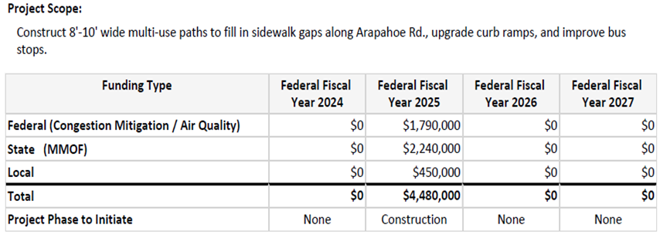

* Amount of reallocated funding requested - Up to $4 Million
* Original Project description - Construct 8'-10' wide multi-use paths to fill in sidewalk gaps along Arapahoe Rd., upgrade curb ramps, and improve bus
* Describe any increase of scope of the Project - Today there is a wood wall that was erected by CDOT probably 60 years ago located on the north side of Arapahoe Rd. and runs parallel to the Algonquin neighborhood. To add the needed sidewalk, we need to replace this failing wall. CDOT is fine without it being a sound wall which does keep the cost down.
* Reason/justification of the need for additional funding - Centennial has worked diligently with CDOT on the structural wall that separates the Algonquin Acres north of Arapahoe Road (between Potomac and Jordan) with SH 88. Due to inflation costs and the shear cost of structural components on a project, the project can only construct a TREX fence to separate the Algonquin Acres neighborhood from SH 88. If additional funding was provided for the project, the wall structure would be upgraded from a TREX structure to a composite block wall, a post and panel wall or some other structural wall on top of a barrier that will not be technically a sound wall, but still; provide a multitude of benefits including some type of headlight mitigation, and sound mitigation for the adjacent residential neighborhood. The cost estimates below are additional information to support this request.

