Why Housing Matters
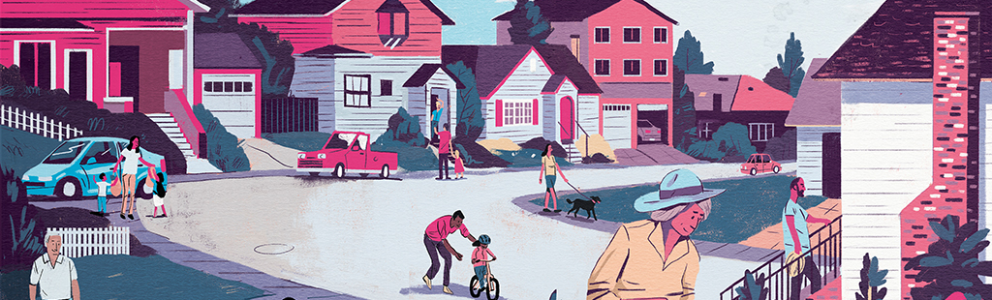
Our homes shape our lives every day. They are where we live, raise our families, and grow old. Housing is at the center of many issues we care about, such as health, climate resiliency, equality, traffic reduction, livable places, and economic vitality.

We need more homes to meet our growing needs.
It is getting harder for friends and neighbors to find housing that works for them. We need more homes overall and more options for our communities—whether it’s an affordable apartment, a place to start and grow a family, or a smaller home for aging in place.
Our biggest gap is homes for low-income households and aging adults.
Recent analyses show that we need:
52,000  more homes to meet current unmet needs | 216,000  more homes over the next ten years | 511,000  more homes than we have today by 2050
And the type of housing we need is changing, too. For example: many older adults want smaller homes that are in or close to the neighborhoods where they already live.
[Consider adding information about current and projected housing needs in your community here.]

Our region has shared housing challenges.
Housing affordability affects us all. Every community—urban and rural, large and small, new and old—is finding it harder to create homes that workers can afford and to meet our changing needs.
By working together, we can get more done.
Learning and sharing solutions  to common problems | Sharing resources and doing more  with less | Bringing together home builders and financers | Strengthening our regional ecosystem to achieve change

What the Denver Regional Council of Governments is Doing
DRCOG is bringing together government officials, housing providers, advocates, and funders across our region to collaborate in addressing our shared housing needs.
  We completed a Regional Housing Needs Assessment to understand the shared housing challenges our region faces. | We are gathering information on housing efforts across the region to better understand what is working, what isn't, and what's missing. | We are getting input to shape the outline of a regional housing strategy: what we want to achieve and how we can best work together.


More Resources
  Learn about our region’s housing needs | Learn about our regional housing strategy |   [Add other relevant links]

[INSERT LOCAL LOGO HERE]

What [NAME OF YOUR CITY/ORGANIZATION] is Doing
[INSERT A SHORT PARAGRAPH OF LOCAL HOUSING EFFORTS; Lorem ipsum dolor sit amet, consectetur adipiscing elit. Sed a blandit nisi. Vestibulum rhoncus nisl nec laoreet mollis. Phasellus congue, quam vel lacinia congue, lacus nisi finibus sapien, sed malesuada mi tortor vitae tellus. Nullam sagittis, libero sed feugiat pretium, velit velit placerat neque, sed scelerisque risus magna at urna. Sed laoreet urna nunc, efficitur eleifend sapien faucibus sit amet. Sed pretium commodo urna, non auctor eros pretium gravida. Curabitur facilisis purus ac ligula sodales, id finibus nibh volutpat. Ut fringilla vel dolor nec fermentum. Nam maximus posuere lacus a aliquet. Donec egestas pretium metus a tincidunt. Etiam eget porttitor felis. Curabitur metus eros, porta vitae purus eu, blandit dapibus risus. Praesent quis eros tortor.]
- [INSERT A BULLET POINT OF LOCAL HOUSING EFFORTS]
- [INSERT A BULLET POINT OF LOCAL HOUSING EFFORTS]
- [INSERT A BULLET POINT OF LOCAL HOUSING EFFORTS]
Your voice matters in shaping solutions!
[Add opportunities to get involved in your community]
- [INSERT A BULLET POINT OF OPPORTUNITY TO GET INVOLVED]
- [INSERT A BULLET POINT OF OPPORTUNITY TO GET INVOLVED]
- [INSERT A BULLET POINT OF OPPORTUNITY TO GET INVOLVED]
Questions? Contact [fill in local contact information]

